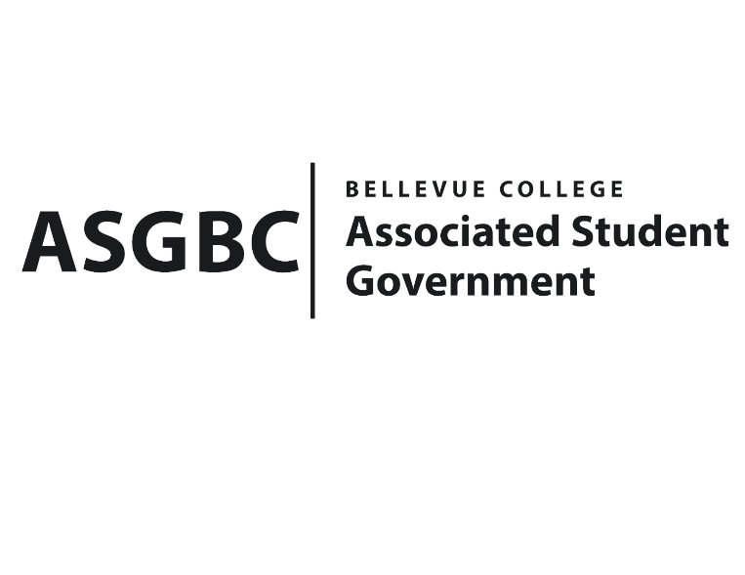
BOARD OF DIRECTORS
Session I
Date: May 3rd 2024
03-01-48

Submitted by Heidi Ngo Treasurer

BOARD BILL 03-01-48 - An Act to Approve Funding for the United Nations Association Conference in the amount of $5,917.91.

WHEREAS: The Bellevue College United Nations Association plans to host a conference event due to the inactivity their club has had over the past years, and their current members are inexperienced in conferences. By making this event, they wish to prepare future representatives of our college so that they could achieve better results in upcoming conferences. Furthermore, though this event we will be able to select a number of passionate students that we think would be willing to put forward more effort in representing our college. In addition, this event may be used as a foundation for current officers to handpick potential officers to secure the future of the clubs; and

WHEREAS: The Bellevue College United Nations Association plans to give students a feel of what a conference will be like. They will understand basic rules, objectives and formalities that are upheld in each conference. Second, students will be able to improve their public speaking skills as every conference requires students to speak out their minds in front of other participants, it may inspire fellow participants on deciding their future careers.

THEREFORE, BE IT ENACTED BY THE ASSOCIATED STUDENT GOVERNMENT OF BELLEVUE COLLEGE BOARD OF DIRECTORS

THAT: The Associated Student Government of Bellevue College approves the allocation of $4611.5 to fund the Bellevue College United Nations Association funding request; and

THAT: The approved funding is allocated from the ASG General account; and,

THAT: A copy of this bill be forwarded to Heid Ngo, Treasurer and Hristo Stoynov, Office of Student Engagement Program Coordinator, Christina Sciabarra, The Bellevue College United Nations Association
Advisor, and Daniella Salima, The Bellevue College United Nations Association President.
End

I, Sean Behl, President of the Associated Student Government of Bellevue College, do herby certify that Board Bill 03-01-48 was duly approved by the Board of Directors on 05/03/2024. I attest to the accuracy and authenticity of the contents of this bill.


__________________________________
Sean Behl
ASG President

