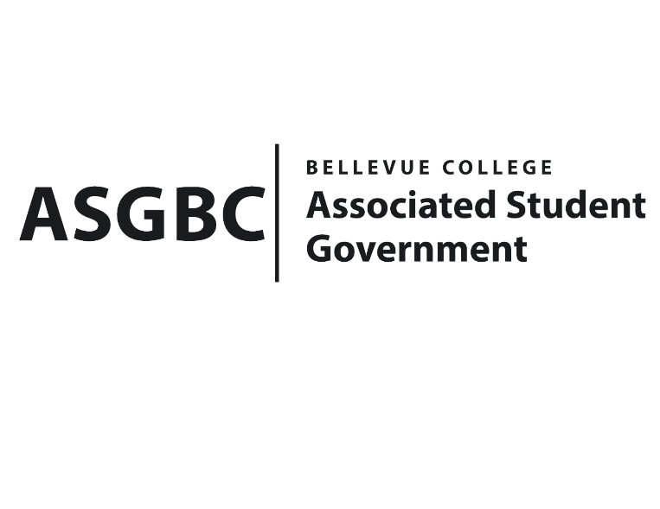
BOARD OF DIRECTORS
Session I
Date: May 3rd 2024
03-01-46

Submitted by Heidi Ngo Treasurer

BOARD BILL 03-01-46 - An Act to Approve Funding for the South Asian Student Association Eid Event in the Amount of $4631.5.

WHEREAS: The Bellevue College South Asian Student Association plans to host an Eid event, a vibrant celebration, bringing together students of diverse backgrounds to connect with other students; and

WHEREAS: The Bellevue College South Asian Student Association will support their learning outcomes by gaining teamwork and more experience working as a group and organizing more events.

THEREFORE, BE IT ENACTED BY THE ASSOCIATED STUDENT GOVERNMENT OF BELLEVUE COLLEGE BOARD OF DIRECTORS

THAT: The Associated Student Government of Bellevue College approves the allocation of $4611.5 to fund the Bellevue College South Asian Student Association funding request; and

THAT: The approved funding is allocated from the ASG Cultural account; and,

THAT: A copy of this bill be forwarded to Heid Ngo, Treasurer and Hristo Stoynov, Office of Student Engagement Program Coordinator, Kelli Callahan, The Bellevue South Asian Student Association Advisor, and Malaika Kamran Khan, The Bellevue College South Asian Student Association President.
End

I, Sean Behl, President of the Associated Student Government of Bellevue College, do herby certify that Board Bill 03-01-46 was duly approved by the Board of Directors on 05/03/2024. I attest to the accuracy and authenticity of the contents of this bill.


__________________________________
Sean Behl
ASG President

