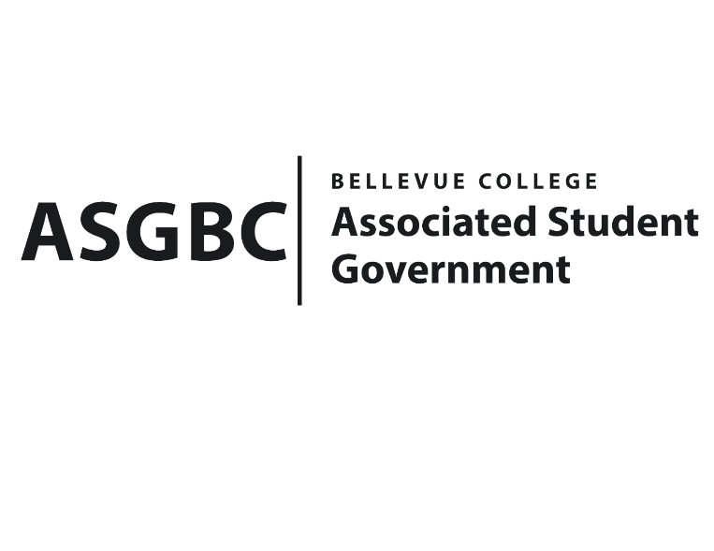
BOARD OF DIRECTORS
Session I
Date: April 19th, 2024
03-01-42

Submitted by Heidi Ngo Treasurer

BOARD BILL 03-01-42 - An Act to Approve Funding for the Vietnamese Student Association First Kick Off Event in the Amount of $640.00

WHEREAS: The Bellevue College Vietnamese Student Association plans to host their first meeting to present opportunities to showcase the vibrancy of Vietnamese culture to Bellevue College students. It also serves as a platform to raise awareness of our clubs and gain recognition from our peers, particularly among the Vietnamese student community; and

WHEREAS: The Bellevue College Vietnamese Student Association aims to promote their vision of fostering a community where individuals can proudly celebrate their cultural heritage and language, while also providing a space for people to immerse themselves in new cultural experiences.

THEREFORE, BE IT ENACTED BY THE ASSOCIATED STUDENT GOVERNMENT OF BELLEVUE COLLEGE BOARD OF DIRECTORS

THAT: The Associated Student Government of Bellevue College approves the allocation of $333.10 to fund the Vietnamese Student Association’s funding request; and

THAT: The approved funding is allocated from the ASG Cultural account; and,

THAT: A copy of this bill be forwarded to Heid Ngo, Treasurer and Hristo Stoynov, Office of Student Engagement Program Coordinator, Katie Dang, Vietnamese Student Association Advisor, and Doan Pham, Vietnamese Student Association President.
End

I, Sean Behl, President of the Associated Student Government of Bellevue College, do herby certify that Board Bill 03-01-16 was duly approved by the Board of Directors on 02/16/2024. I attest to the accuracy and authenticity of the contents of this bill.



__________________________________
Sean Behl
ASG President

