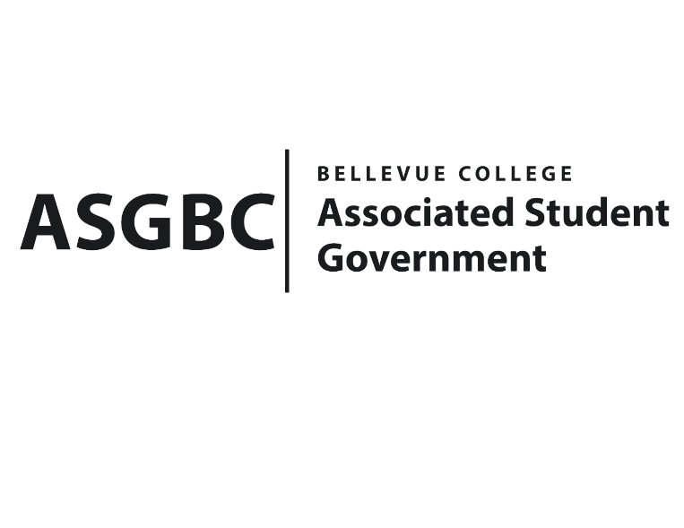
BOARD OF DIRECTORS
Session I
Date: April 19th, 2024
03-01-41

Submitted by Heidi Ngo Treasurer

BOARD BILL 03-01-41 - An Act to Approve Funding for the Bellevue College Music Club and Korean Student Association First Kick-Off Event in the Amount of $1370.50.

WHEREAS: The Bellevue College Music Club and Korean Student Association plans to host a collaborative event promising a unique blend of tradition and entertainment; and

WHEREAS: The Bellevue College Music Club and Korean Student Association will support their visions and goals by creating a supportive community where members collaboratively create and publish original music, and be close with music; and

WHEREAS: The Bellevue College Music Club and Korean Student Association’s event will support camaraderie and teamwork along members. They will have an opportunity to network with all the music lovers and have a fun time.

THEREFORE, BE IT ENACTED BY THE ASSOCIATED STUDENT GOVERNMENT OF BELLEVUE COLLEGE BOARD OF DIRECTORS

THAT: The Associated Student Government of Bellevue College approves the allocation of $1570.60 to fund the Music Club and Korean Student Association’s funding request; and

THAT: The approved funding is allocated from the ASG General account; and,

THAT: A copy of this bill be forwarded to Heid Ngo, Treasurer and Hristo Stoynov, Office of Student Engagement Program Coordinator, Cynthia Weintraub, Music Club Advisor, and Seungmin Cha, Music Club President.
End

I, Sean Behl, President of the Associated Student Government of Bellevue College, do herby certify that Board Bill 03-01-41 was duly approved by the Board of Directors on 04/19/2024. I attest to the accuracy and authenticity of the contents of this bill.



__________________________________
Sean Behl
ASG President

