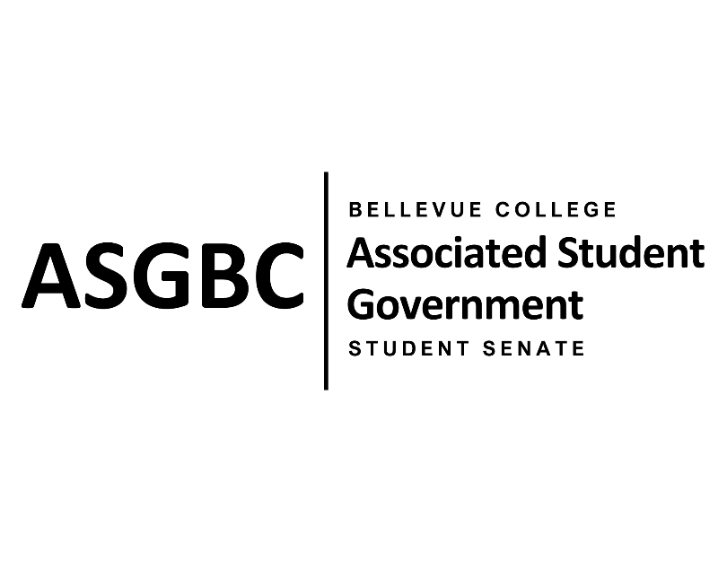

ASG Student Senate Meeting Agenda
March 12th, 2024 | N-201| 5:30-7
Next Meeting: April 9th, 2024

- CALL TO ORDER
  - Rebecca Mbaka calls the meeting to order at 5:37pm

- ROLL CALL
  - Speaker: Rebecca Mbaka (present)
  - Vice Speaker: Stephanie Nehema (present)
  - Clerk: Sienna Jarrard (present)
  - Arts and Humanities Senator: Katrina Gunvaldson (present)
  - Business and Technology: Zoe Mukaba (present)
  - Health Science, Education, and Wellness Institute: Cornelie Aloma (absent, unexcused)
  - Social Science: Adam Gong (present)
  - Science: Marita Bwalya (tardy)
  - Housing: Lucy Ju (present)
  - Athletics: Kes Smith (absent, excused)
  - Running Start: Mumina Guled (present)
  - International: Graciella Nzowo (present)
  - At-Large: Merveil Kalala (present)
  - At-Large: Daniella Salima (tardy)
  - At-Large: Marie Lumiere Kawende (present)
  - At-Large: Emmanuel Ngoie (present)
  - At-Large: Vallon Bosango (present)

- INTRODUCTIONS
  - Sean Behl- ASG President
  - Amy McCrory- ASG and Senate Advisor
  - Heidi Ngo- ASG Treasurer

- APPROVAL OF AGENDA
  - Emmanuel Ngoie motions, Marie Lumiere Kawende seconds, motion passes by (9-0-0)
- APPROVAL OF MINUTES
  - Graciella Nzowo motions, Vallon Bosango seconds, motion passes by (9-0-0)
- OPEN FORUM
  - No participants
- REPORTS
  - Speaker
    - The Speaker has been unable to meet with the Board of Directors to discuss Senate resolutions but has gotten feedback from Sean.
- UNFINISHED BUSINESS
  - SENATE RESOLUTION SR-01-06: A Suggestion for a Constant and Regular Technical Maintenance Check Throughout the Campus
    - Marita Bwalya and Marie Lumiere Kawende present a resolution to suggest a more frequent technical maintenance check of the computers and printers on campus.
    - The resolution requests that the Bellevue College Technology Service Desk implement regular maintenance checks and provide a system to easily report and track technical issues.
    - Graciella Nzowo motions to approve the resolution, Daniella Salima seconds, motion passes by (11-0-0)
  - SENATE RESOLUTION SR-01-07: Improving Food Safety and Awareness at the Benefits Hub
    - Zoe Mukaba and Cornelie Aloma present a resolution to improve food safety and awareness at the Benefits Hub.
    - The resolution requests that the Benefits Hub administration follow established food expiration guidelines, monitor food expiration in the pantry and remove expired items.
    - The resolution also requests that Bellevue College commit to providing robust support and resources to ensure timely restocking, increase food options, and support minimizing the occurrence of expired food items.
    - Marie Lumiere Kawende motions to approve the resolution, Katrina Gunvaldson seconds, motion passes by (11-0-0)
  - SENATE RESOLUTION SR-01-08: A Resolution to Promote a Higher Balance for Students’ Orca Cards
    - Vallon Bosango and Kes Smith present a resolution to promote a higher balance for student Orca cards.
    - The resolution requests that the Bellevue College transportation department allow students to purchase both an Orca Blue Card and Orca Silver card on a quarterly basis.
    - Graciella Nzowo motions to table the resolution indefinitely, Mumina Guled seconds, motion passes by (11-0-0)
- NEW BUSINESS
  - SENATE RESOLUTION SR-01-09: Addressing Lighting Issues Around Campus
    - Daniella Salima and Katrina Gunvaldson present a resolution to address lighting issues around campus.
    - The resolution requests that the Office of Campus Operations in collaboration with Bellevue College Public Safety upgrade, replace, fix or install lighting where it is needed on campus.
    - Marita Bwalya motions to refer the resolution to the Board of Directors for review, Vallon Bosango seconds, motion passes by (11-0-0)
- DISCUSSION ITEMS
  - Hiring
    - Hiring for the Board of Directors is open until March 31^{st.}
    - Hiring for the Student Senate, Office of Events and Community Relations, and Office of Civic Engagement will open on April 1st.
  - Quarterly Reports
    - Quarterly reports are coming up and will be due April 16th.
  - Senate and Board of Directors Activity
    - The activity will be held 3-4:30 in N201 with potluck, games, and activities.
  - One-on-Ones
    - All Senators will be having a one-on-one meeting with Rebecca in the beginning of Spring Quarter.
- ANNOUNCEMENTS
  - Graciella Nzowo announces that her club, Communication and Leadership Club, is having regular meetings and invites everyone to join.
- ADJOURNMENT
  - Stephanie Nehema motions, Daniella Salima seconds, Rebecca Mbaka adjourns at 6:59pm.

