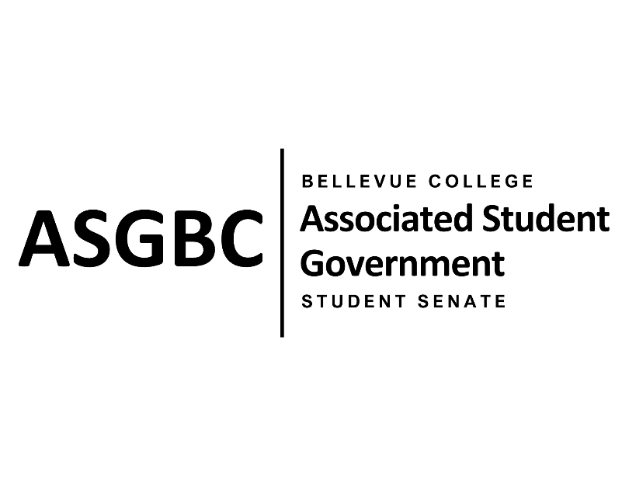

ASG Student Senate Meeting Agenda
April 9th, 2024 | N-201| 5:30-7
Next Meeting: April 16th, 2024

- CALL TO ORDER
  - Rebecca Mbaka calls the meeting to order at

- ROLL CALL
  - Speaker: Rebecca Mbaka (present)
  - Vice Speaker: Stephanie Nehema (present)
  - Clerk: Sienna Jarrard (present)
  - Arts and Humanities Senator: Katrina Gunvaldson (present)
  - Business and Technology: Zoe Mukaba (present)
  - Health Science, Education, and Wellness Institute: Cornelie Aloma (present)
  - Social Science: Adam Gong (present)
  - Science: Marita Bwalya (present)
  - Housing: Lucy Ju (present)
  - Athletics: Kes Smith (present)
  - Running Start: Mumina Guled (present)
  - International: Graciella Nzowo (present)
  - At-Large: Merveil Kalala (present)
  - At-Large: Daniella Salima (present)
  - At-Large: Marie Lumiere Kawende (present)
  - At-Large: Emmanuel Ngoie (present)
  - At-Large: Vallon Bosango (present)

- INTRODUCTIONS
  - Name-Title (if applicable)
  - Name-Title (if applicable)

- APPROVAL OF AGENDA
- APPROVAL OF MINUTES
- OPEN FORUM
- REPORTS
  - Speaker
    - The Speaker has been…
- UNFINISHED BUSINESS
  - SENATE RESOLUTION SR-01-06: A Suggestion for a Consistent and Regular Technical Maintenance Check Throughout the Campus.
  - SENATE RESOLUTION SR-01-09: Addressing Lighting Issues Around Campus
- NEW BUSINESS
- DISCUSSION ITEMS
  - One-on-Ones with Rebecca
  - Senate Hiring
  - Academic Success Center and Fees
  - Tardies
  - Quarterly Reports
  - Election of Senators
- ANNOUNCEMENTS
  - Senator announces that…
- ADJOURNMENT

