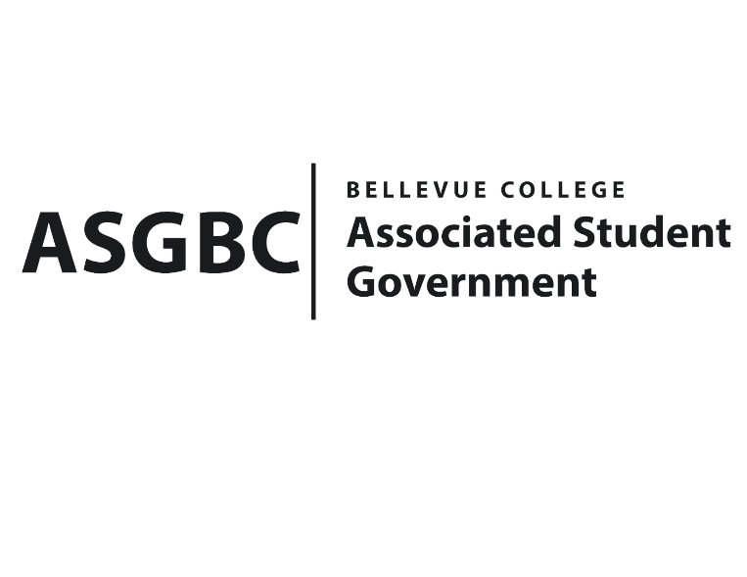
ASG Board of Directors Meeting Minutes
April 19th, 2024 | B-201| 12:30-1:30
Next Meeting: April 26th, 2024

- CALL TO ORDER
  - Chair Sean Behl calls the meeting to order at 12:31

- ROLL CALL
  - President: Sean Behl (present)
  - Vice President: Rebecca Mbaka (absent, excused)
  - Executive Justice: Daniel Ngoy (present)
  - Treasurer: Heidi Ngo (present)
  - Secretary: Julie Nguyen (present)
  - Public Relations Rep: Joyce Diakubama (present)
  - Events Rep: Sienna Jarrard (present)
  - Social Responsibility Rep: Stephanie Nehema (present)
  - Emerging Technology Rep: Isadora Silva (present)

- INTRODUCTIONS
  - Jaehyun Lee – Co-President of Bellevue College Music Club
  - Seungmin Cha - Co-President of Bellevue College Music Club
  - Doan Pham – President of Bellevue College Vietnamese Student Association
  - Hai Thanh Vo – Vice President of Bellevue College Vietnamese Student Association

- APPROVAL OF AGENDA
  - Daniel Ngoy motions, Julie Nguyen seconds, motion passes by (8-0-0)
- APPROVAL OF MINUTES
  - Julie Nguyen motions, Daniel Ngoy seconds, motion passes by (8-0-0)
- OPEN FORUM
  - There were no Board members interested in participating in the open forum.
- REPORTS
  - President
    - The President has been working on the hiring process, election for the Board next year.
    - The President has also been working with the Board members to make sure they are on the right track for their tasks and projects.
    - The President has also been working with the Treasurer on reviewing S&A budget request for next year.
    - The President has also been working with Sienna Jarrard and Daniel Ngoy on legislative efforts and WSA Assembly.
  - Vice President
    - The Vice President has been…
  - Executive Justice
    - The Executive Justice has been working on gathering data from the survey given out to students regarding WSA legislation.
    - The Executive Justice has also been working on planning for the first training session, which will be on April 29th, for students who are interested in learning more about advocating for legislation.
  - Treasurer
    - The Treasurer has been working on reviewing funding requests and communicating with clubs to make sure all materials are ready for the Board of Directors meeting.
    - The Treasurer has also been working on writing Board Bills for funding requests and club charters.
    - The Treasurer has also been working on reviewing S&A budget requests for next year.
    - The Treasurer reports $52,436 and $340,274 remaining in the ASG Cultural and General account.
  - Secretary
    - The Secretary has been working on preparing Agendas and Minutes for the Board of Directors meeting.
    - The Secretary has also been working on sending emails recap to clubs regarding ASG decision from last week Board of Directors meeting.
    - The Secretary has also been working on the ASG Tabling Involvement Fair to advertise more about the Senate applications and ASG in general.
  - Public Relations Rep.
    - The Public Relations Rep. has been working on attending the Citation Committee meeting.
    - The Public Relations Rep. has also been working on building the election event advertising campaign.
    - The Public Relations Rep. has also been working on representing ASG during the Tabling Involvement Fair.
  - Events Rep.
    - The Events Rep. has been working on planning for the ASG Gala, which will be on Jun 6th.
    - The Events Rep. has also been working on planning election events (tabling, panel, candidate’s debate, and voting process)
    - The Events Rep. has been working on hiring Senate & the Office positions, the applications are currently open.
    - The Events Rep. has also been working on building a schedule for upcoming ASG Board interviews.
  - Social Responsibility Rep.
    - The Social Responsibility Rep. has been working on meeting with the Senate regarding the upcoming Senate hiring process.
    - The Social Responsibility Rep. has also been working on scheduling and attending the SESF meeting.
    - The Social Responsibility Rep. has also been attending the ASG Involvement Fair to represent ASG.
    - The Social Responsibility Rep. has been working on planning for the upcoming Earth Month with the SESF committee.
  - Emerging Technology Rep.
    - The Emerging Technology Rep. has been working on keeping the ASG website updated (Agendas & Minutes)
- UNFINISHED BUSINESS
- NEW BUSINESS
  - Board Bill 03-01-41 - An Act to Approve Funding for the Bellevue College Music Club and Korean Student Association First Kick-off Event in the Amount of $1,370.50
- Funds requested will be used to cover food/beverages costs, prizes, estimated for 130 students.
- Daniel Ngoy motions, Sienna Jarrard seconds, motion passes by (8-0-0)
  - Board Bill 03-01-42 - An Act to Approve Funding for the Bellevue College Vietnamese Student Association First Meeting in the Amount of $640.00
- The funds requested will be used to cover food/beverages costs, and prizes, estimated for 30 students.
- Sienna Jarrard motions to amend the request to $640.00, which will be estimated to cover for 60 students, Daniel Ngoy seconds, motion passes by (8-0-0)
  - Board Bill 04-01-39 - An Act to Approve the Charter of the Bellevue College Hong Kong Student Association.
- Sienna Jarrard motions, Heidi Ngo seconds, motion passes by (7-0-1)
  - Board Bill 04-01-40 – An Act to Propose Amendments to the Bellevue College Governance Charter.
- Joyce Diakubama motions, Heidi Ngo seconds, motion passes by (7-0-1)
- DISCUSSION ITEMS
- ANNOUNCEMENTS
  - Sienna Jarrard announces upcoming events:
+ Candidate tabling – April 16th, C building, 1-2:30pm
+ Totes & Floats Candidate Panel – April 23rd, Cafeteria, 1-2:30pm
+ Donuts & Debate – April 30th, Cafeteria, 1-2:30pm
+ Voting Process – May 6th-9th, Courtyard, 11-2:30pm
- ADJOURNMENT
  - Sienna Jarrard motions, Daniel Ngoy seconds, the meeting is adjourned at 12:58

