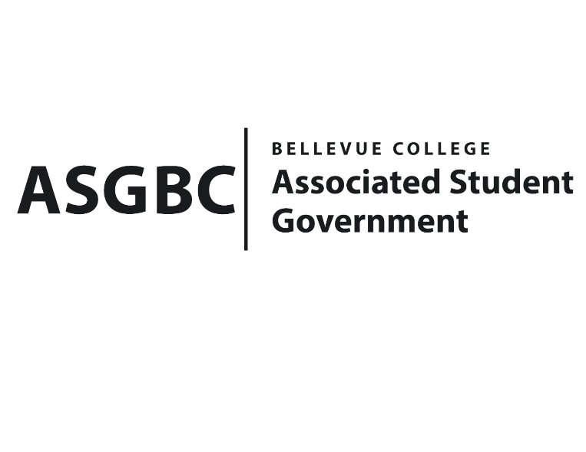
ASG Board of Directors Meeting Minutes
April 12th, 2024 | B-201 | 12:30-1:30
Next Meeting: April 19th, 2024

- CALL TO ORDER
  - Chair Sean Behl calls the meeting to order at 12:30

- ROLL CALL
  - President: Sean Behl (present)
  - Vice President: Rebecca Mbaka (present)
  - Executive Justice: Daniel Ngoy (present)
  - Treasurer: Heidi Ngo (present)
  - Secretary: Julie Nguyen (present)
  - Public Relations Rep: Joyce Diakubama (present)
  - Events Rep: Sienna Jarrard (absent, excused)
  - Social Responsibility Rep: Stephanie Nehema (present)
  - Emerging Technology Rep: Isadora Silva (present)

- INTRODUCTIONS
  - Michael Kaptik – Dean of Student Life/ ASG Co-Advisor
  - Brandon Lowder – Vice President of Bellevue College Programming Club
  - Kuan-Ying Liao – President of Bellevue College Tech Startup Club
  - Ethan Leonard – President of Bellevue College Programming Club
  - Habiba Elswify – President of Bellevue College AI + Ethics Club
  - Abraham Guan – President of Bellevue College Tech Club
  - Michelle Lee – Officer of Bellevue College Taiwanese Student Association
  - Max Shaw – Vice President of Bellevue College Stage Fright Drama Club
  - Kate Peterson – Vice President of Bellevue College Stage Fright Drama Club
  - Kris Dessin – President of Bellevue College Stage Fright Drama Club
  - Ciel Fostest – Teasurer of Bellevue College Stage Fright Drama Club
  - Dan Nzowo – Vice President of Bellevue College Computer Leadership Club
  - Isaac Alsehikz – President of of Bellevue College Aerospace and Rocketry Club
- APPROVAL OF AGENDA
  - Daniel Ngoy motions, Rebecca Mbaka seconds, motion passes by (8-0-0)
- APPROVAL OF MINUTES
  - Stephanie Nehema motions, Julie Nguyen seconds, motion passes by (8-0-0)
- OPEN FORUM
  - There were no Board members interested in participating in the open forum.
- REPORTS
  - President
    - The President has been working on the hiring process, election, and the application is currently opening.
    - The President has also been with Sienna Jarrard and Daniel Ngoy on legislative efforts, as well as the WSA Assembly.
    - The President has also been working on Student Senate application with Rebecca Mbaka, Sienna Jarrard, and Stephanie Nehema.
  - Vice President
    - The Vice President has been having 1-on-1 meeting with the Senator.
    - The Vice President has also been working on the Cap & Gown Project, which will be available for students to rent them for graduation.
  - Executive Justice
    - The Executive Justice has been working on having meeting and training on WSA process.
  - Treasurer
    - The Treasurer has been communicating with campus clubs on funding requests.
    - The Treasurer has also been reviewing the Funding Requests for the Board of Directors meeting.
    - The Treasurer has also been working on S&A, reviewing the club budget requests for next academic year.
    - The Treasurer reports ASG cultural budget: $52,436 and General Budget: $340,274
  - Secretary
    - The Secretary has been preparing and distributing weekly meeting and Board of Directors meeting' Agendas and Minutes.
    - The Secretary has also been helping and collaborating for ASG Spring Kick-off event.
  - Public Relations Rep.
    - The Public Relations Rep. has been working on doing reports and setting goals for this quarter.
  - Events Rep.
    - The Events Rep. has been…
  - Social Responsibility Rep.
    - The Social Responsibility Rep. has been working on the Senate hiring process.
    - The Social Responsibility Rep. has also been working on tasks and office hours for this Spring quarter.
  - Emerging Technology Rep.
    - The Emerging Technology Rep. has been updating websites and in the process of setting up the second upcoming STF meeting.
- UNFINISHED BUSINESS
- NEW BUSINESS
  - Board Bill 03-01-36 - An Act to Approve Funding for the Central Asian Students Association Nauryz Event in the Amount of $9,250.
- There is lack of information about the expenses and the break-down.
- Daniel Ngoy motions, Joyce Diakubama seconds, motion passes by (0-8-0)
- Rebecca Mbaka motions to table the funding request to the next meeting, Julie Nguyen seconds, motion passes by (8-0-0)
  - Board Bill 03-01-37 - An Act to Approve Funding for the Aerospace and Rocketry in the Amount of $953.27.
- Funds requested will be used to purchase some missing components for the rocket.
- Daniel Ngoy motions, Julie Nguyen seconds, motion passes by (8-0-0)
  - Board Bill 03-01-38 - An Act to Approve Funding for Bellevue College Computer Programming Club, Tech Club, Tech Startup Club, and AI+Ethics’ Hackathon event in the Amount of $30,093.
- Funds requested will be used for Hackathon event, covering room reservation, food catering, printing costs, and prizes for students.
- Isadora Silva motions, Heidi Ngo seconds, motion passes by (8-0-0)
  - Board Bill 03-01-39 - An Act to Approve Funding for the Bellevue College Stage Fright Drama Club’s Scripts, Performance Royalties and Recording Rights in the Amount of $737.
- Funds requested will be used to cover printing costs, production copy license, and the performance expenses.
- Daniel Ngoy motions, Isadora Silva seconds, motion passes by (0-8-0)
- Isadora Silva motions to amend the amount to $861.11, Rebecca Mbaka seconds, motion passes by (7-0-1)
  - Board Bill 03-01-40 - An Act to Approve Funding for the Bellevue College Taiwanese Student Association to promote the Taiwanese Culture and Raise Money for Future Events in the Amount of $256.00
- Funds will be used to purchase supplies and materials to make the Taiwanese dessert.
- TSA will be doing fundraising for the club’s future events and activities.
- Daniel Ngoy motions, Heidi Ngo seconds, motion passes by (8-0-0)
  - Board Bill 02-01-21 - An Act to Appoint Amy McCrory to the 2023-2024 Electoral Committee.
- Isadora Silva motions, Daniel Ngoy seconds, motion passes by (7-0-1)
  - Board Bill 04-01-33 - An Act to Approve the Charter of the Bellevue College LGBTQ+ Arts and Crafts Club.
- Julie Nguyen motions, Joyce Diakubama seconds, motion passes by (5-0-2)
  - Board Bill 04-01-34 - An Act to Approve the Charter of the Bellevue College Math Club.
- Heidi Ngo motions, Julie Nguyen seconds, motion passes by (7-0-0)
  - Board Bill 04-01-35 - An Act to Approve the Charter of the Bellevue College TechBiz Club.
- Julie Nguyen motions, Joyce Diakubama seconds, motion passes by (6-0-1)
  - Board Bill 04-01-36 - An Act to Approve the Charter of the Bellevue College Cambodian Student Association.
- Heidi Ngo motions, Julie Nguyen seconds, motion passes by (7-0-0)
  - Board Bill 04-01-37 - An Act to Approve the Charter of the Bellevue College Equal Opportunities in STEM.
- Joyce Diakubama motions, Daniel Ngoy seconds, motion passes by (7-0-0)
  - Board Bill 04-01-38 - An Act to Pardon Stephanie Nehema on the Basis of Not Meeting the Credit Requirements for Spring Quarter 2024.
- Stephanie Nehema is doing a reduce course-load since she is graduating and Spring is her last quarter.
- Joyce Diakubama motions, Heidi Ngo seconds, motion passes by (6-0-1)
- DISCUSSION ITEMS
  - There were no Board members interested in making an announcement.
- ANNOUNCEMENTS
  - Board Member announces that Senate application is currently opening for students.
- ADJOURNMENT
  - Daniel Ngoy motions, Joyce Diakubama seconds, the meeting is adjourned at 1:33

