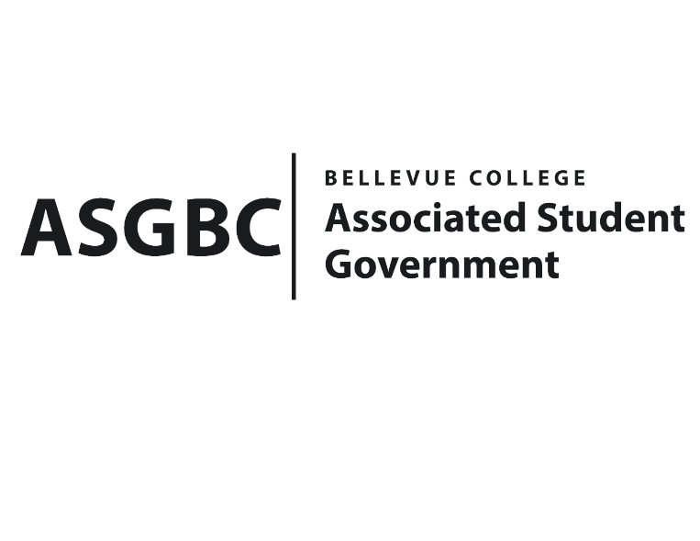
ASG Board of Directors Meeting Agenda
April 26th, 2024 | B-201 | 12:30-1:30
Next Meeting: May 3rd, 2024

- CALL TO ORDER
  - Chair Sean Behl calls the meeting to order at

- ROLL CALL
  - President: Sean Behl (present)
  - Vice President: Rebecca Mbaka (present)
  - Executive Justice: Daniel Ngoy (present)
  - Treasurer: Heidi Ngo (present)
  - Secretary: Julie Nguyen (present)
  - Public Relations Rep: Joyce Diakubama (present)
  - Events Rep: Sienna Jarrard (present)
  - Social Responsibility Rep: Stephanie Nehema (present)
  - Emerging Technology Rep: Isadora Silva (present)

- INTRODUCTIONS
  - Name-Title (if applicable)
  - Name-Title (if applicable)

- APPROVAL OF AGENDA

- APPROVAL OF MINUTES

- OPEN FORUM

- REPORTS
  - President
    - The President has been…
  - Vice President
    - The Vice President has been…
  - Executive Justice
    - The Executive Justice has been…
  - Treasurer
    - The Treasurer has been…
  - Secretary
    - The Secretary has been…
  - Public Relations Rep.
    - The Public Relations Rep. has been…
  - Events Rep.
    - The Events Rep. has been…
  - Social Responsibility Rep.
    - The Social Responsibility Rep. has been…
  - Emerging Technology Rep.
    - The Emerging Technology Rep. has been…
- UNFINISHED BUSINESS
- NEW BUSINESS
  - Board Bill 03-01-43 - An Act to Approve Funding for the Bellevue College Business Leadership Community Alumni Night Event in the Amount of $2,800.00
  - Board Bill 03-01-44 - An Act to Approve Funding for the Bellevue College Business Leadership Community Providence Event in the Amount of $1,200.00
  - Board Bill 03-01-45 - An Act to Approve Funding for the Bellevue Computer Programming Club AI Guest Speaker Event in the Amount of $1,225.00
  - Board Bill 03-01-46 - An Act to Approve Funding for the Bellevue College South Asian Student Association Eid Event in the Amount of $4,540.00
  - Board Bill 03-01-47 - An Act to Approve Funding for the Bellevue College Tech Startup Club Meeting in the Amount of $2,983.60
  - Board Bill 04-01-41 - An Act to Ratify the SESF Request for Isla Trip Budget Adjustment of $2500
  - Board Bill 04-01-42 - An Act to Approve the SESF Committee Recommendation to Approve the SESF Budget Allocation from the Reserve Account to the Fund Account in the amount of $500,000.
  - SR-01-11 – A Resolution to Suggest the Creation of a Student Life Canvas Course.
  - SR-01-12 – A Resolution to Further Subsidize ORCA Cards and Increase Allocation Amounts.
- DISCUSSION ITEMS
  - SR-01-13 – A Resolution to Address Rental Costs and Hourly Minimums for Students on the 3rd Floor of the U-building.
- ANNOUNCEMENTS
  - Board Member announces that…
- ADJOURNMENT

