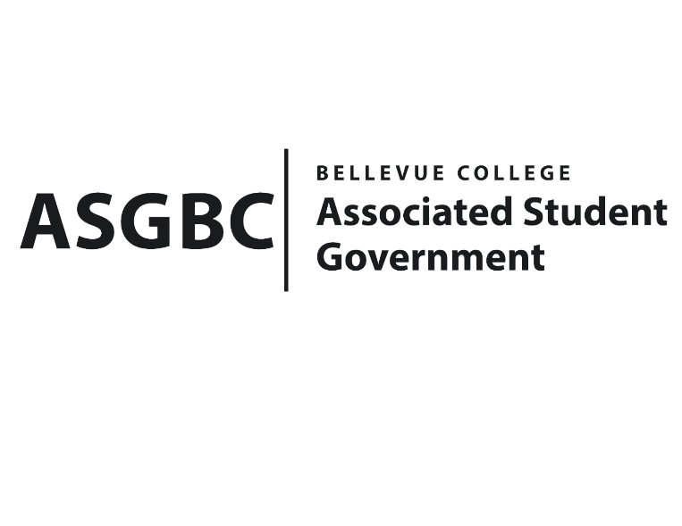
ASG Board of Directors Meeting Agenda
April 19th, 2024 | B-201| 12:30-1:30
Next Meeting: April 26th, 2024

- CALL TO ORDER
  - Chair Sean Behl calls the meeting to order at 12:30

- ROLL CALL
  - President: Sean Behl (present)
  - Vice President: Rebecca Mbaka (present)
  - Executive Justice: Daniel Ngoy (present)
  - Treasurer: Heidi Ngo (present)
  - Secretary: Julie Nguyen (present)
  - Public Relations Rep: Joyce Diakubama (present)
  - Events Rep: Sienna Jarrard (present)
  - Social Responsibility Rep: Stephanie Nehema (present)
  - Emerging Technology Rep: Isadora Silva (present)

- INTRODUCTIONS
  - Name-Title (if applicable)
  - Name-Title (if applicable)

- APPROVAL OF AGENDA

- APPROVAL OF MINUTES

- OPEN FORUM

- REPORTS
  - President
    - The President has been…
  - Vice President
    - The Vice President has been…
  - Executive Justice
    - The Executive Justice has been…
  - Treasurer
    - The Treasurer has been…
  - Secretary
    - The Secretary has been…
  - Public Relations Rep.
    - The Public Relations Rep. has been…
  - Events Rep.
    - The Events Rep. has been…
  - Social Responsibility Rep.
    - The Social Responsibility Rep. has been…
  - Emerging Technology Rep.
    - The Emerging Technology Rep. has been…
- UNFINISHED BUSINESS
- NEW BUSINESS
  - Board Bill 03-01-41 - An Act to Approve Funding for the Bellevue College Music Club and Korean Student Association First Kick-off Event in the Amount of $1,370.50
  - Board Bill 03-01-42 - An Act to Approve Funding for the Bellevue College Vietnamese Student Association First Meeting in the Amount of $333.10
  - Board Bill 04-01-39 - An Act to Approve the Charter of the Bellevue College Hong Kong Student Association.
  - SB-01-01 – A Recommendation to the Board of Directors to Enact Nominal Voluntary Student Fees to Ensure the Sustainability of the Services and Activities Fee Process.
  - SR-01-11 – A Resolution to Suggest the Creation of a Student Life Canvas Course.
  - SR-01-12 – A Resolution to Further Subsidize ORCA Cards and Increase Initial Distribution Amounts.
- DISCUSSION ITEMS

- ANNOUNCEMENTS
  - Board Member announces that…
- ADJOURNMENT

