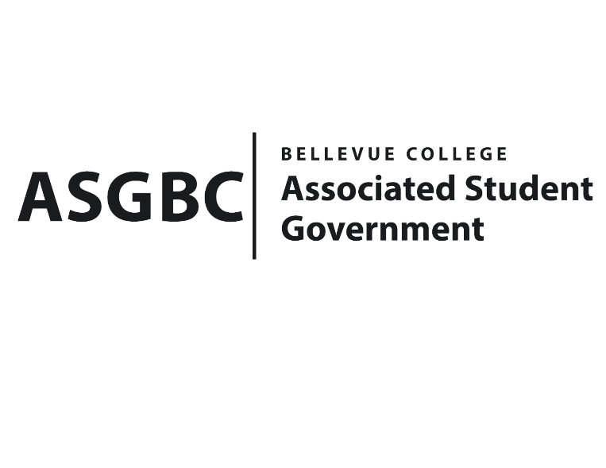
BOARD OF DIRECTORS
Session I
Date: March 15th, 2024
04-01-32

Submitted by Sean Behl, President

BOARD BILL 04-01-32: An Act to Pardon Julie Nguyen on the Basis of Not Meeting the Credit Requirements for Spring Quarter 2024.

WHEREAS: Julie Nguyen is unable to meet the credit requirement of eight credits for spring quarter 2024; and,

WHEREAS: Julie Nguyen is graduating in spring 2024, and only needs to take five credits to graduate; and,

WHEREAS: The ASG Bylaws clearly states “If for any reason any ASG Officer fails to be registered for a minimum of eight (8) BC credit hours, this Officer must inform the Board of Directors of this matter within five (5) business days after the deadline to drop a class without receiving a “W” grade on their transcript;” and,

WHEREAS: The ASG Bylaws clearly states “The decision to grant a pardon to the Officer not meeting the credit requirements must be approved by the Board of Directors through a two-thirds (2/3) majority vote, excluding abstentions. If the vote to grant a pardon fails, the ASG Officer in question will immediately forfeit their position. An Officer may only receive the pardon described above once during their tenure in office.”

THEREFORE, BE IT ENACTED BY THE ASSOCIATED STUDENT GOVERNMENT OF BELLEVUE COLLEGE BOARD OF DIRECTORS

THAT: The ASG Board of Directors hereby pardon Julie Nguyen on the basis of not meeting the credit requirement; and,

THAT: A copy of this bill be forwarded to Julie Nguyen, ASG Secretary; Amy McCrory, ASG Advisor; and Mike Kaptik, Dean of Student Life and Leadership/ASG Advisor.

End

I, Sean Behl, President of the Associated Student Government of Bellevue College, do herby certify that Board Bill 04-01-32 was duly approved by the Board of Directors on 03/15/2024. I attest to the accuracy and authenticity of the contents of this bill.



__________________________________
Sean Behl
ASG President

