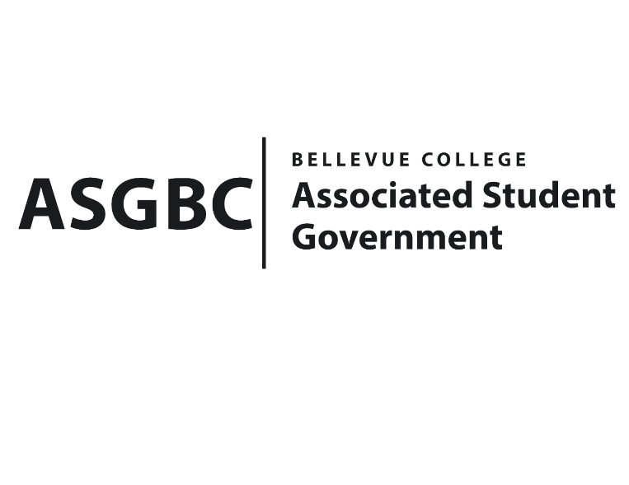
BOARD OF DIRECTORS
Session I
Date: March 15th, 2024
04-01-31

Submitted by Heidi Ngo, Treasurer

BOARD BILL 04-01-31: An Act to Approve the Charter of the Bellevue College Healthcare Club.

WHEREAS: The Bellevue College Healthcare Club aims to build and maintain bridges between BC students, medical professionals, and the local healthcare community. This group intends to serve students in all grade levels (running start, undergrad, postbac, etc.) by providing opportunities to connect with each other, guest speakers, and prepare for future careers in different healthcare fields; and

WHEREAS: The Bellevue College Healthcare Club’s vision is to empower students interested in careers in healthcare to discover various fields and provide them with community and personal growth opportunities; and

WHEREAS: The Bellevue College Healthcare Club’s goals are to goals are to champion dignity and belonging in the medical field through human connection; to build and maintain bridges between BC students, medical professionals, and the community; and to uphold Bellevue College’s vision, core values, and mission; and

WHEREAS: The Bellevue College Healthcare Club has met all required qualifications to become a chartered student organization; and

WHEREAS: This charter shall expire on June 30th, 2024, unless otherwise renewed by the club with ratification from the Board of Directors.

THEREFORE, BE IT ENACTED BY THE ASSOCIATED STUDENT GOVERNMENT OF BELLEVUE COLLEGE BOARD OF DIRECTORS
THAT: The Associated Student Government hereby recognizes the Bellevue College Healthcare Club as an official student organization at Bellevue College; and

THAT: A copy of this bill be forwarded to Julie Nguyen, ASG Secretary; Joyce Diakubama, ASG Public Relations Representative; Amanda Arboleda, Student Engagement- Student Involvement Specialist; Jennifer Prekeges, Bellevue College Healthcare Club Advisor; LaJoyce Martin, Bellevue College Healthcare Club President.

End

I, Sean Behl, President of the Associated Student Government of Bellevue College, do herby certify that Board Bill 04-01-31 was duly approved by the Board of Directors on 03/15/2024. I attest to the accuracy and authenticity of the contents of this bill.



__________________________________
Sean Behl
ASG President

