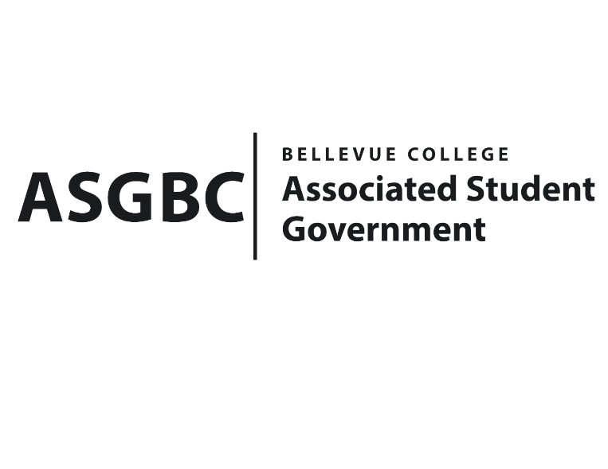
BOARD OF DIRECTORS
Session I
Date: March 15th, 2024
04-01-30

Submitted by Heidi Ngo, Treasurer

BOARD BILL 04-01-30: An Act to Approve the Charter of the Bellevue College Congolese Student Success Association.

WHEREAS: The Bellevue College Congolese Student Success Association intends to improve the learning of CSSA members through mentoring. They also want to provide a balance between academic and social development by providing effective leadership opportunities through events and programs; and

WHEREAS: The Bellevue College Congolese Student Success Association plans to promote the understanding of the culture and heritage of Congo, while promoting curiosity to learn from other culture. They also intend to encourage a commitment to excellence in the day-to-day functioning of the CSSA organization and keep its members at the standard of excellence and dedication to the organization's mission; and

WHEREAS: The Bellevue College Congolese Student Success Association plans to Promote diversity by including the other community of Bellevue college and keep strong partnerships with other student organization.

WHEREAS: The Bellevue College Congolese Student Success Association has met all required qualifications to become a chartered student organization; and

WHEREAS: This charter shall expire on June 30th, 2024, unless otherwise renewed by the club with ratification from the Board of Directors.
THEREFORE, BE IT ENACTED BY THE ASSOCIATED STUDENT GOVERNMENT OF BELLEVUE COLLEGE BOARD OF DIRECTORS
THAT: The Associated Student Government hereby recognizes the Bellevue College Congolese Student Success Association as an official student organization at Bellevue College; and
THAT: A copy of this bill be forwarded to Julie Nguyen, ASG Secretary; Joyce Diakubama, ASG Public Relations Representative; Amanda Arboleda, Student Engagement- Student Involvement Specialist; Jean D'arc Campbell, Bellevue College Congolese Student Success Association Advisor; Marie Lumiere Kawende, Bellevue College Congolese Student Success Association President.

End

I, Sean Behl, President of the Associated Student Government of Bellevue College, do herby certify that Board Bill 04-01-30 was duly approved by the Board of Directors on 03/15/2024. I attest to the accuracy and authenticity of the contents of this bill.



__________________________________
Sean Behl
ASG President

