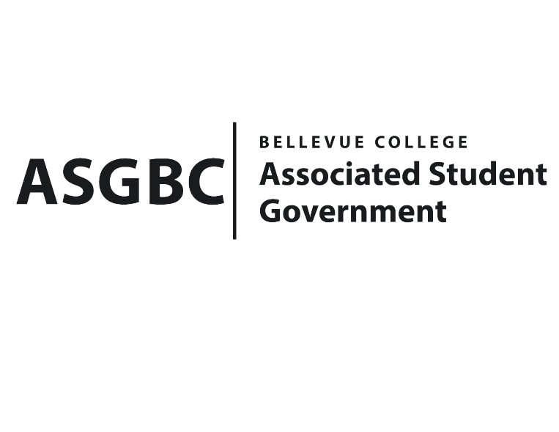
BOARD OF DIRECTORS
Session I
Date: March 15th, 2024
03-01-33

Submitted by Sean Behl, President

BOARD BILL 03-01-33: An Act to Approve Funding for the ASG Board of Directors Washington DC Student Advocacy Trip in the amount of $24,000.

WHEREAS: The ASG Board of Directors intends to travel to Washington DC to advocate for student issues including campus safety, and the expansion of the Pell grant to congresspeople and their staff; and,

WHEREAS: The total cost of this trip is $24,000.

THEREFORE, BE IT ENACTED BY THE ASSOCIATED STUDENT GOVERNMENT OF BELLEVUE COLLEGE BOARD OF DIRECTORS

THAT: The ASG Board of Directors is allocated $24,000 to fund their Washington DC Student Advocacy Trip; and,

THAT: A copy of this bill be sent to Julie Nguyen, ASG Secretary; Hristo Stoynov, Office of Student Engagement Program Coordinator and Amy McCrory, ASG Advisor.

End

I, Sean Behl, President of the Associated Student Government of Bellevue College, do herby certify that Board Bill 03-01-33 was duly approved by the Board of Directors on 03/15/2024. I attest to the accuracy and authenticity of the contents of this bill.



__________________________________
Sean Behl
ASG President

