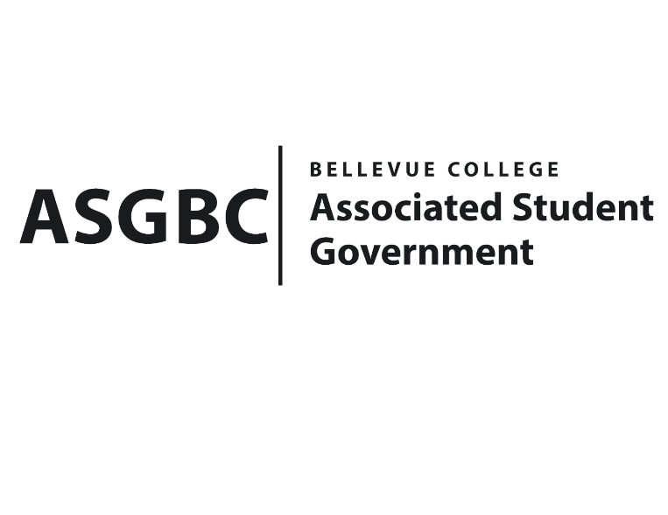
BOARD OF DIRECTORS
Session I
Date: March 15th, 2024
03-01-32

Submitted by Sean Behl, President; at the request of Mike Kaptik, Dean of Student Life and Leadership

BOARD BILL 03-01-32: An Act to Reallocate Funds from the Office of Student Engagement Account to the Associated Student Government Account in the amount of $40,000.

WHEREAS: There is $67,131 remaining in lapsed salary from the Office of Student Engagement 2023-2024 S&A budget ask; and,

WHEREAS: The ASG Board of Directors and the Office of Student Engagement have expressed interest in a mutual division of the remaining funds; and,

WHEREAS: A reallocation of $40,000 from the Office of Student Engagement account to the ASG account was mutually agreed upon between the parties; and,

WHEREAS: The Office of Student Engagement retaining $27,131 was mutually agreed upon between the parties.

THEREFORE, BE IT ENACTED BY THE ASSOCIATED STUDENT GOVERNMENT OF BELLEVUE COLLEGE BOARD OF DIRECTORS

THAT: $40,000 is reallocated from the Office of Student Engagement account to the ASG account; and,

THAT: The Office of Student Engagement retains $27,131; and,

THAT: A copy of this bill be forwarded to Heidi Ngo, ASG Treasurer; Hristo Stoynov, Office of Student Engagement Program Coordinator; Bradley Huggins, Director of Student Engagement; and Mike Kaptik, Dean of Student Life and Leadership.

End
I, Sean Behl, President of the Associated Student Government of Bellevue College, do herby certify that Board Bill 03-01-32 was duly approved by the Board of Directors on 03/15/2024. I attest to the accuracy and authenticity of the contents of this bill.



__________________________________
Sean Behl
ASG President

