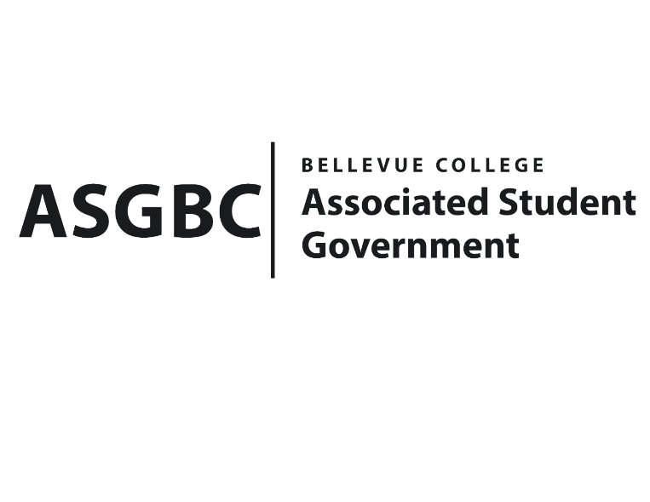
BOARD OF DIRECTORS
Session I
Date: March 15^{tht}, 2024
03-01-29

Submitted by Heidi Ngo Treasurer

BOARD BILL 03-01-28: An Act to Approve the African Arab Student Association funding request in the amount of $6,600.

WHEREAS: The Bellevue African Arab Student Association plans on hosting an Iftar event for the month Ramadan. Iftar is a dinner party where Muslims break their fasts together; and
WHEREAS: The Bellevue African Arab Student Association Ramadan Iftar event aims to supports their missions and goals by creating a safe, welcoming community for all those who celebrate to come and break their fast.

THEREFORE, BE IT ENACTED BY THE ASSOCIATED STUDENT GOVERNMENT OF BELLEVUE COLLEGE BOARD OF DIRECTORS

THAT: The Associated Student Government of Bellevue College approves the allocation of $5000 to fund the African Arab Student Association’s Ramadan Iftar Event; and,

THAT: The approved funding is allocated from the ASG Cultural account; and,

THAT: A copy of this bill be forwarded to Heid Ngo, Treasurer and Hristo Stoynov, Office of Student Engagement Program Coordinator, Aseel Kabakri, Bellevue College African Arab Student Association Advisor; and Jude Goreish, Bellevue College African Arab Student Association.

End

I, Sean Behl, President of the Associated Student Government of Bellevue College, do herby certify that Board Bill 03-01-29 was duly approved by the Board of Directors on 03/15/2024. I attest to the accuracy and authenticity of the contents of this bill.



__________________________________
Sean Behl
ASG President

