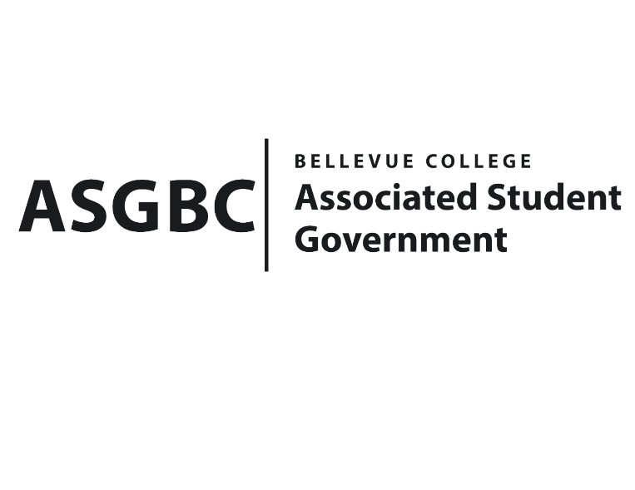
BOARD OF DIRECTORS
Session I
Date: March 1st, 2024
03-01-28

Submitted by Heidi Ngo Treasurer

BOARD BILL 03-01-28: An Act to Approve the Stage Fright Drama Club’s funding request in the amount of $300.00

WHEREAS: The Bellevue College Stage Fright Drama Club plans to host an ode to Animation, which is an end of quarter celebration featuring a performance from the BC Stage Fright; and,
WHEREAS: The Bellevue College Stage Fright Drama club aims to showcase the talent and the hard work that Stage Fright students have put into their scenes and monologues that will be performed at the event. It is a great opportunity for socialization and meeting others who are interested in the theatre.

THEREFORE, BE IT ENACTED BY THE ASSOCIATED STUDENT GOVERNMENT OF BELLEVUE COLLEGE BOARD OF DIRECTORS

THAT: The Associated Student Government of Bellevue College approves the allocation of $318.11 to fund the Stage Fright Drama Club's Ode to Animation- End of Quarter Celebration; and,

THAT: The approved funding is allocated from the ASG General account; and,

THAT: A copy of this bill be forwarded to Heid Ngo, Treasurer and Hristo Stoynov, Office of Student Engagement Program Coordinator, Karen Jo Fairbrook Stage Fright Drama Club Advisor, and Kris Dessin, Stage Fright Drama Club President.
End

I, Sean Behl, President of the Associated Student Government of Bellevue College, do herby certify that Board Bill 03-01-28 was duly approved by the Board of Directors on 03/01/2024. I attest to the accuracy and authenticity of the contents of this bill.



__________________________________
Sean Behl
ASG President

