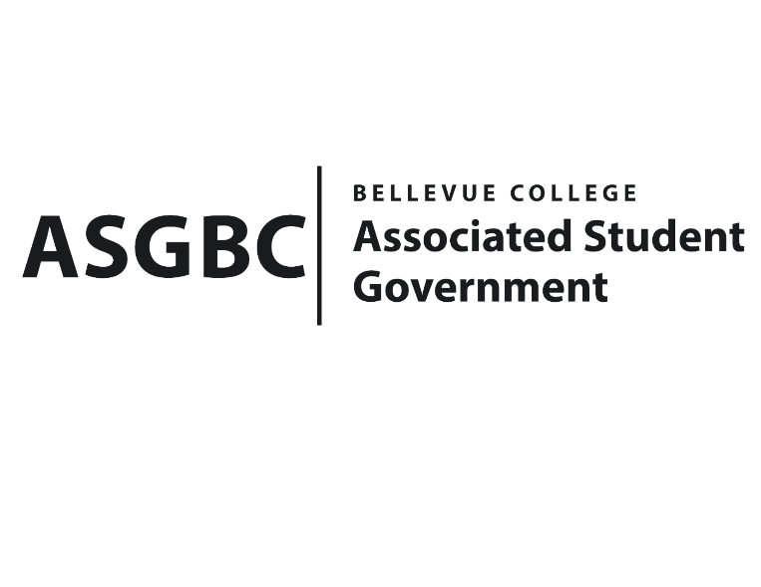
BOARD OF DIRECTORS
Session I
Date: March 1st, 2024
03-01-26

Submitted by Heidi Ngo Treasurer

BOARD BILL 03-01-26: An Act to Approve the Taiko Club’s funding request in the amount of $6,540.

WHEREAS: The Bellevue College Taiko Club plans to host 90-minute weekly Taiko drum lessons, instructed by a professional Taiko performer/instructor. The instructor is providing the Taiko drums for members to play & practice music with, so they would like to request funds for the instruction & materials fee; and,

WHEREAS: The Bellevue College Taiko Club will promote their club by funding for posters, snacks and drinks for their workshop open to any BC student and;

WHEREAS: The Bellevue College Taiko Club aims to help members gain basic techniques and learn to play proficiently.

THEREFORE, BE IT ENACTED BY THE ASSOCIATED STUDENT GOVERNMENT OF BELLEVUE COLLEGE BOARD OF DIRECTORS

THAT: The Associated Student Government of Bellevue College approves the allocation of $7,372 to fund the Taiko Club's Club Meeting and Workshop Event; and

THAT: The approved funding is allocated from the ASG Cultural account; and,

THAT: A copy of this bill be forwarded to Heid Ngo, Treasurer and Hristo Stoynov, Office of Student Engagement Program Coordinator, Naeim Rahmani Taiko Club Advisor, and Seinosuke Ueda, Taiko Club President.
End

I, Sean Behl, President of the Associated Student Government of Bellevue College, do herby certify that Board Bill 03-01-26 was duly approved by the Board of Directors on 03/15/2024. I attest to the accuracy and authenticity of the contents of this bill.



__________________________________
Sean Behl
ASG President

