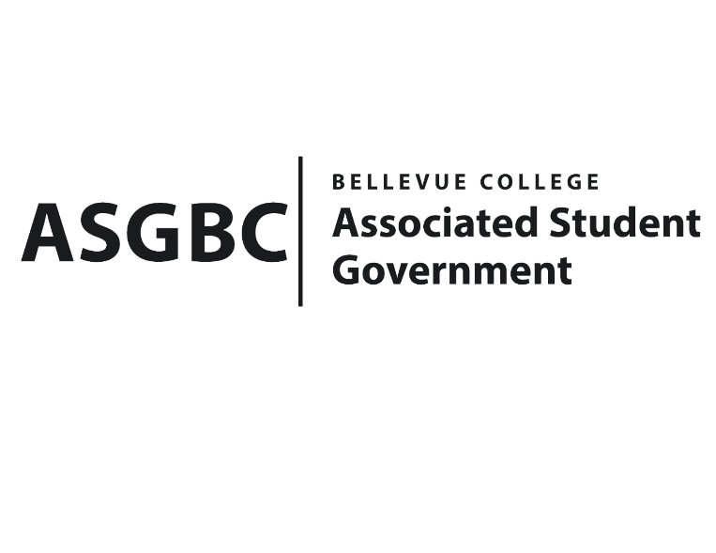
BOARD OF DIRECTORS
Session I
Date: February 16, 2024
03-01-20

Submitted by Heidi Ngo, Treasurer

BOARD BILL 03-01-20: An Act to Ratify the SESF Committee Recommendation for the SalmonSafe Assessment and Certification in the Amount $22000
WHEREAS: The Office of Sustainability plans to bring the organization, SalmonSafe, to campus to evaluate the water runoff on campus and ensure campus is safe for salmon nearby; and

WHEREAS: Once evaluated by the organization, the campus will officially be Salmon Safe certified.

WHEREAS: The SESF Committee has approved the allocation of $22000 for the SalmonSafe Assessment and Certification.

THEREFORE, BE IT ENACTED BY THE ASSOCIATED STUDENT GOVERNMENT OF BELLEVUE COLLEGE BOARD OF DIRECTORS

THAT: The Associated Student Government of Bellevue College approves the allocation of $22000 to fund the SalmonSafe.

THAT: A copy of this bill be forwarded to Heidi Ngo, Treasurer; Hristo Stoynov, Office of Student Engagement Program Coordinator, and the SESF Committee.

End

I, Sean Behl, President of the Associated Student Government of Bellevue College, do herby certify that Board Bill 03-01-20 was duly approved by the Board of Directors on 02/16/2024. I attest to the accuracy and authenticity of the contents of this bill.



__________________________________
Sean Behl
ASG President

