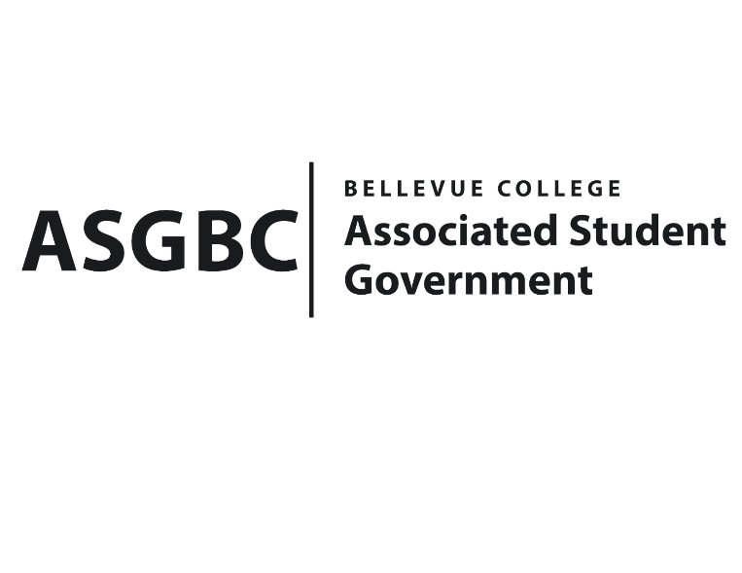
BOARD OF DIRECTORS
Session I
Date: February 9th, 2024
03-01-14

Submitted by Sienna Jarrard, Events Representative

BOARD BILL 03-01-14: An Act to Approve the Allocation of Funds for ASG Merchandise in the Amount of $10,500.

WHEREAS: The Associated Student Government of Bellevue College seeks to promote awareness of and involvement in ASG operations; and,

WHEREAS: The Associated Student Government of Bellevue College has not allocated money for custom merchandise for students this academic year; and,

WHEREAS: The Associated Student Government of Bellevue College has minimal merchandise for students left due to the increase of tabling and outreach we did in Fall 2023; and,

WHEREAS: The Associated Student Government of Bellevue College merchandise has been requested by students and has proven to be a great tool during outreach and will be an asset for our upcoming hiring season.

THEREFORE, BE IT ENACTED BY THE ASSOCIATED STUDENT GOVERNMENT OF BELLEVUE COLLEGE BOARD OF DIRECTORS

THAT: The Associated Student Government of Bellevue College approves the allocation of $10,500 to fund various merchandise to be used for the remainder of the 2023-2024 academic year and for the beginning of the 2024-2025 academic year; and

THAT: A copy of this bill be forwarded to Heidi Ngo, Treasurer, and Hristo Stoynov, Office of Student Engagement Program Coordinator.
End
I, Sean Behl, President of the Associated Student Government of Bellevue College, do herby certify that Board Bill 03-01-14 was duly approved by the Board of Directors on 02/09/2024. I attest to the accuracy and authenticity of the contents of this bill.



__________________________________
Sean Behl
ASG President

