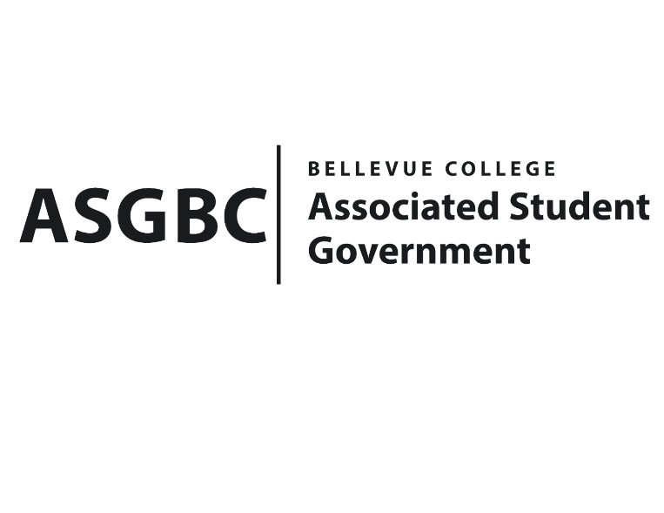
BOARD OF DIRECTORS
Session I
Date: March 15th, 2024
02-01-10

Submitted by Sienna Jarrard, Events Representative

BOARD BILL 02-01-10: An Act to Appoint Kes Smith to the Electoral Committee for the 2023-2024 Academic Year.
WHEREAS: Kes Smith has been serving as the Associated Student Government Athletics Senator for the 2023-2024 academic year; and,

WHEREAS: Kes Smith has shown interest in serving as the Senate representative as a voting member of the Electoral Committee.

THEREFORE, BE IT ENACTED BY THE ASSOCIATED STUDENT GOVERNMENT OF BELLEVUE COLLEGE BOARD OF DIRECTORS

THAT: Kes Smith be appointed to the Electoral Committee for the 2023-2024 academic year; and,

THAT: A copy of this bill be forward to Kes Smith; Sean Behl, ASG President; Mike Kaptik, Vice Chair of the Electoral Committee; Julie Nguyen, ASG Secretary; and Sienna Jarrard, ASG Events Representative and Chair of the Electoral Committee

End

I, Sean Behl, President of the Associated Student Government of Bellevue College, do herby certify that Board Bill 02-01-10 was duly approved by the Board of Directors on 03/15/2024. I attest to the accuracy and authenticity of the contents of this bill.



__________________________________
Sean Behl
ASG President

