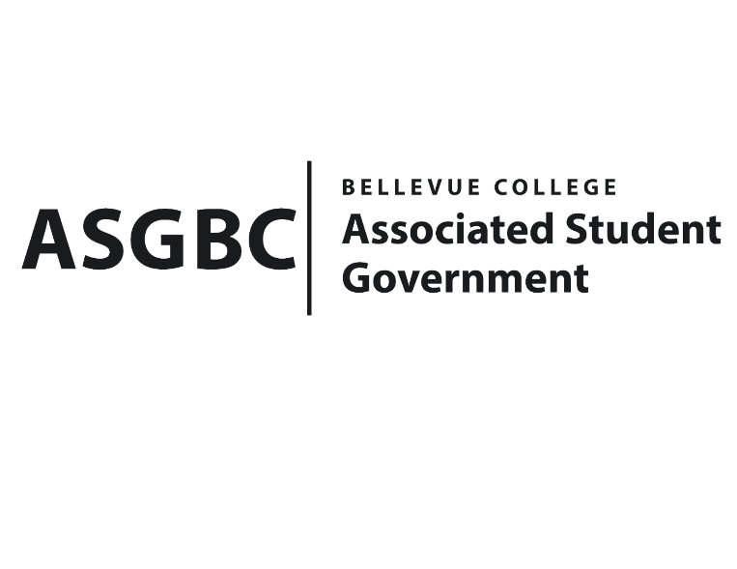
BOARD OF DIRECTORS
Session I
Date: March 1st, 2024
02-01-07
Submitted by Rebecca Mbaka, Vice President

BOARD BILL 02-01-07: An Act to Appoint the Membership of the Student Commencement Speaker Committee.

WHEREAS: The Student Commencement Speaker Committee is to select a student speaker who will deliver an inspiring and memorable commencement speech at the graduation ceremony. The committee aims to identify candidates who can effectively represent the student body, share meaningful insights, and inspire their fellow graduates as they embark on the next chapter of their lives. Additionally, the committee strives to create a fair and transparent selection process that considers the diverse perspectives and achievements of potential speakers. Ultimately, the goal is to ensure that the chosen speaker delivers a speech that resonates with the graduating class and leaves a lasting impact on all attendees; and,

WHEREAS: The Student Commencement Speaker process will be starting from March 5th, 2024, to March 21st, 2024; and,

WHEREAS: The Student Commencement Speaker Committee plays a vital role in orchestrating a memorable and meaningful graduation experience for all students, faculty, and guests involved.

THEREFORE, BE IT ENACTED BY THE ASSOCIATED STUDENT GOVERNMENT OF BELLEVUE COLLEGE BOARD OF DIRECTORS

THAT: The student commencement committee is composed of 6 people Chair Rebecca Mbaka (non voting); ASG Advisor: Mike Kaptik; ASG Officer: Daniel Ngoy; Faculty: Bruce Wolcott; Staff: Aidrien Wilkins; ASG Senator: Kes Smith; and Student-at-large: Katana Hewett); and,

THAT: A copy of this bill be forwarded to the commencement committee members.

End

I, Sean Behl, President of the Associated Student Government of Bellevue College, do herby certify that Board Bill 02-01-07 was duly approved by the Board of Directors on 03/01/2024. I attest to the accuracy and authenticity of the contents of this bill.



__________________________________
Sean Behl
ASG President

