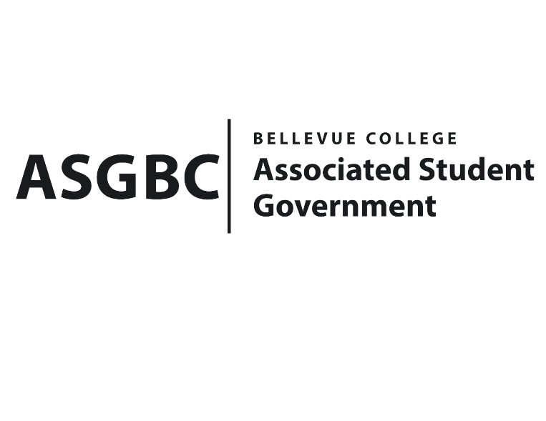
BOARD OF DIRECTORS
Session I
Date: February 16^{h}, 2024
04-01-25

Submitted by Heidi Ngo, Treasurer

BOARD BILL 04-01-25: An Act to Approve the Charter of the Bellevue College Students for Justice Club.
WHEREAS: The Bellevue Students for Justice Club aims to shed light on global issues happening around us and advocate for marginalized groups around the world that tend to be overlooked despite the challenges they face. Promoting justice, equality, and human rights is their most priority and they plan to discuss these topics further. Students of various backgrounds are encouraged to participate and bring up challenges that other groups face that they might not be aware of. They plan to take steps towards raising the voices and pushing for change; and
WHEREAS: The Bellevue Students for Justice Club’s goal is to goal is to be the voice for the people of Palestine, Congo, Sudan, and others who face hardships by raising awareness and to foster and promote justice and equality for everyone. They plan to host events including in the form of discussions, presentations, workshops, and more to educate students at Bellevue College about issues not as prevalent in the media and may not have heard of previously; and
WHEREAS: The Bellevue Students for Justice Club seeks to welcome all students of various backgrounds and levels of knowledge on these current global issues being faced by marginalized groups including but not limited to Palestine, Sudan, Congo, etc. to further inform them on the atrocities and how they too can join group efforts for collective action; and
WHEREAS: The Bellevue College Students for Justice Club has met all required qualifications to become a chartered student organization; and
WHEREAS: This charter shall expire on June 30th, 2024, unless otherwise renewed by the club with ratification from the Board of Directors.
THEREFORE, BE IT ENACTED BY THE ASSOCIATED STUDENT GOVERNMENT OF BELLEVUE COLLEGE BOARD OF DIRECTORS
THAT: The Associated Student Government hereby recognizes the Bellevue College Students for Justice Club as an official student organization at Bellevue College; and
THAT: A copy of this bill be forwarded to Julie Nguyen, ASG Secretary; Joyce Diakubama, ASG Public Relations Representative; Amanda Arboleda, Student Engagement- Student Involvement Specialist; Bellevue College Students for Justice Club Advisor; Yousra Esseddiqi, Bellevue Students for Justice Club President; and Hedaya Youssef, Bellevue Students for Justice Club Vice President.

End
I, Sean Behl, President of the Associated Student Government of Bellevue College, do herby certify that Board Bill 04-01-25 was duly approved by the Board of Directors on 02/16/2024. I attest to the accuracy and authenticity of the contents of this bill.



__________________________________
Sean Behl
ASG President

