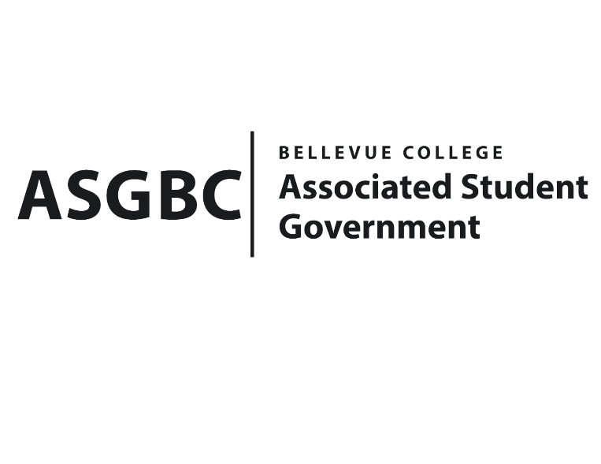
tBOARD OF DIRECTORS
Session I
Date: February 9th, 2024
04-01-22

Submitted by Heidi Ngo, Treasurer

BOARD BILL 04-01-22: An Act to Approve the Charter of the Bellevue College Entrepreneurship and Personal Development Club.
WHEREAS: The Bellevue College Entrepreneurship and Personal Development Club aims to host meetings that offers valuable skills to students who are interested in entrepreneurship, meeting other like-minded individuals, and helping to promote entrepreneurship, innovation, and creativity on campus and in the surrounding Washington area.
WHEREAS: The Bellevue College Entrepreneurship and Personal Development Club aims to get a good understanding of Entrepreneurship and Personal Development. They also want to help students learn more about market analysis, networking skills, practice pitching business ideas, and business plan writing during their meetings and events.
WHEREAS: Bellevue College Entrepreneurship and Personal Development Club has met all required qualifications to become a chartered student organization.
WHEREAS: This charter shall expire on June 30th, 2024, unless otherwise renewed by the club with ratification from the Board of Directors.
THEREFORE, BE IT ENACTED BY THE ASSOCIATED STUDENT GOVERNMENT OF BELLEVUE COLLEGE BOARD OF DIRECTORS
THAT: The Associated Student Government hereby recognizes the Bellevue College Entrepreneurship and Personal Development Club as an official student organization at Bellevue College.
THAT: A copy of this bill be forwarded to Julie Nguyen, ASG Secretary; Joyce Diakubama, ASG Public Relations Representative; Amanda Arboleda, Student Engagement- Student Involvement Specialist; Ithzel Moreno, Bellevue College Entrepreneurship and Personal Development Club Advisor; Jordan Gossier, Bellevue College Entrepreneurship and Personal Development Club President; and Grace Tran, Bellevue College Entrepreneurship and Personal Development Club Vice President.End
I, Sean Behl, President of the Associated Student Government of Bellevue College, do herby certify that Board Bill 04-01-22 was duly approved by the Board of Directors on 02/09/2024. I attest to the accuracy and authenticity of the contents of this bill.



__________________________________
Sean Behl
ASG President

