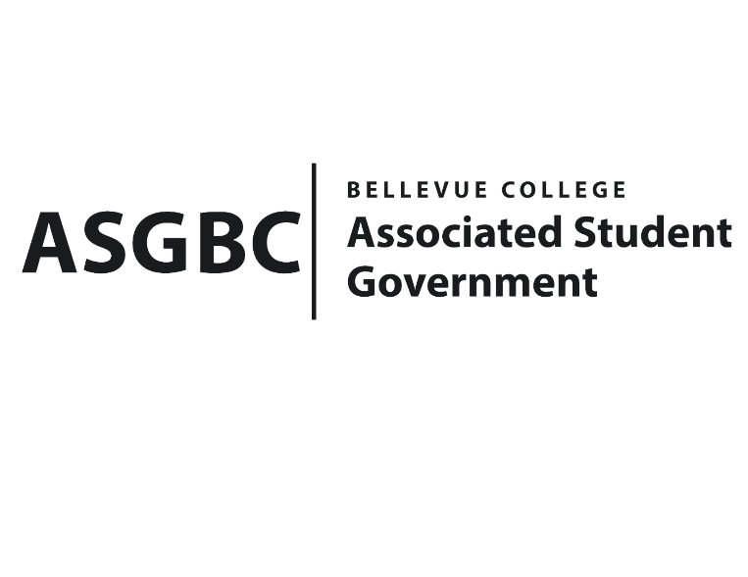
BOARD OF DIRECTORS
Session I
Date: February 2nd, 2024
04-01-21
Submitted by Heidi Ngo, Treasurer

BOARD BILL 04-01-21: An Act to Approve the Charter of the Bellevue College Stage Fright Drama Club.
WHEREAS: The Bellevue College Stage Fright Drama Club seeks to come together as students to have weekly or even twice a week to communicate, socialize, and plan for future events, such as the possibility for productions or an improve team; and
WHEREAS: The Bellevue College Stage Fright Drama Club aims help not only the students in our drama department come together to express their passions, but it will also be a safe space for anyone interested in the art of performance. This organization will be completely democratic, and all students involved will have a voice, and all students who are interested are invited; and
WHEREAS: The Bellevue College Stage Fright Drama Club has met all required qualifications to become a chartered student organization; and
WHEREAS: This charter shall expire on June 30th, 2024, unless otherwise renewed by the club with ratification from the Board of Directors.
THEREFORE, BE IT ENACTED BY THE ASSOCIATED STUDENT GOVERNMENT OF BELLEVUE COLLEGE BOARD OF DIRECTORS
THAT: The Associated Student Government hereby recognizes the Bellevue College Stage Fright Drama Club as an official student organization at Bellevue College.
THAT: A copy of this bill be forwarded to Julie Nguyen, ASG Secretary; Joyce Diakubama, ASG Public Relations Representative; Amanda Arboleda, Student Engagement- Student Involvement Specialist; Kris Dessin, Bellevue College Stage Fright Drama Club; and Max Shaw, Bellevue College Stage Fright Drama Club Vice President.End
I, Sean Behl, President of the Associated Student Government of Bellevue College, do herby certify that Board Bill 04-01-21 was duly approved by the Board of Directors on 02/02/2024. I attest to the accuracy and authenticity of the contents of this bill.



__________________________________
Sean Behl
ASG President

