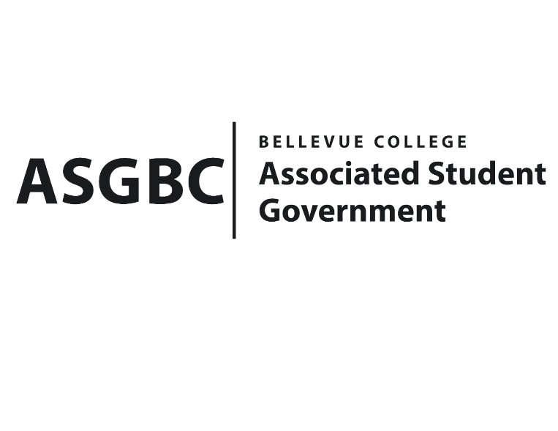
BOARD OF DIRECTORS
Session I
Date: February 2nd, 2024
04-01-20

Submitted by Heidi Ngo, Treasurer

BOARD BILL 04-01-20: An Act to Approve the Charter of the Bellevue College Central Asian Students Association.
WHEREAS: The Bellevue College Central Asian Students Association aims to aspire to make a significant impact on the college community, promoting diversity, inclusivity, and global awareness. We envision a vibrant, inclusive campus community where the diverse cultures and traditions of Central Asia are actively celebrated and respected; and
WHEREAS: The Bellevue College Central Asian Students Association provides educational experiences beyond the classroom, including seminars, workshops, and guest lectures, which enrich the students' academic life and broaden their understanding of Central Asia. It's also a great opportunity for networking, both socially and professionally. For Central Asian students, the association acts as a support system, aiding in their adjustment to college life and providing a space where they can freely express and celebrate their heritage.
WHEREAS: The Bellevue College Central Asian Students Association has met all required qualifications to become a chartered student organization.
WHEREAS: This charter shall expire on June 30th, 2024, unless otherwise renewed by the club with ratification from the Board of Directors.
THEREFORE, BE IT ENACTED BY THE ASSOCIATED STUDENT GOVERNMENT OF BELLEVUE COLLEGE BOARD OF DIRECTORS
THAT: The Associated Student Government hereby recognizes the Bellevue College Central Asian Students Association as an official student organization at Bellevue College.
THAT: A copy of this bill be forwarded to Julie Nguyen, ASG Secretary; Joyce Diakubama, ASG Public Relations Representative; Amanda Arboleda, Student Engagement- Student Involvement Specialist; Azim Askhatov, Bellevue College Central Asian Students Association President; and Ayana Imanbaeva, Central Asian Students Association Vice President.

End

I, Sean Behl, President of the Associated Student Government of Bellevue College, do herby certify that Board Bill 04-01-20 was duly approved by the Board of Directors on 02/02/2024. I attest to the accuracy and authenticity of the contents of this bill.



__________________________________
Sean Behl
ASG President

