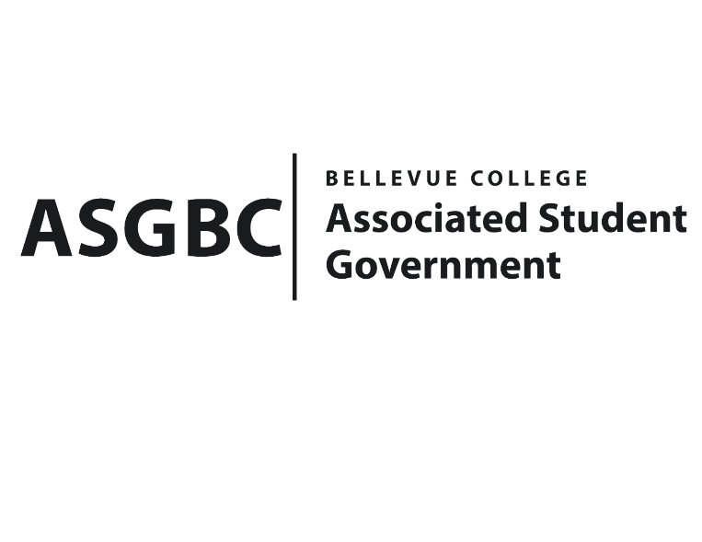
BOARD OF DIRECTORS
Session I
Date: February 23rd, 2024
03-01-23

Submitted by Heidi Ngo Treasurer

BOARD BILL 03-01-23: An Act to Approve the South Asian Student Association and Indian Student Community Club’s funding request in the amount of $8,000.00

WHEREAS: The Bellevue College South Asian Student Association and Indian Student Community Club plans to host a Holi event which is celebrating the festival of colors; and

WHEREAS: The Bellevue College South Asian Student Association and Indian Student Community Club aims to bring people together through South Asian/Indian culture, celebrating diversity and this event is a prime example of us building a stronger community at Bellevue College; and

WHEREAS: The Bellevue College South Asian Student Association and Indian Student Community Club plans to use the funds to purchase food and an activity in which people can play with powdered colors.

THEREFORE, BE IT ENACTED BY THE ASSOCIATED STUDENT GOVERNMENT OF BELLEVUE COLLEGE BOARD OF DIRECTORS

THAT: The Associated Student Government of Bellevue College approves the allocation of $7513.81. To fund the South Asian Student Association and Indian Student Community Club’s Holi Event; and

THAT: The approved funding is allocated from the ASG Culutral account; and,

THAT: A copy of this bill be forwarded to Heid Ngo, Treasurer and Hristo Stoynov, Office of Student Engagement Program Coordinator, Humaira Jackson South Asian Student Association Advisor, and Malaika Kamran Khan, South Asian Student Association President.

End
I, Sean Behl, President of the Associated Student Government of Bellevue College, do herby certify that Board Bill 03-01-23 was duly approved by the Board of Directors on 02/23/2024. I attest to the accuracy and authenticity of the contents of this bill.



__________________________________
Sean Behl
ASG President

