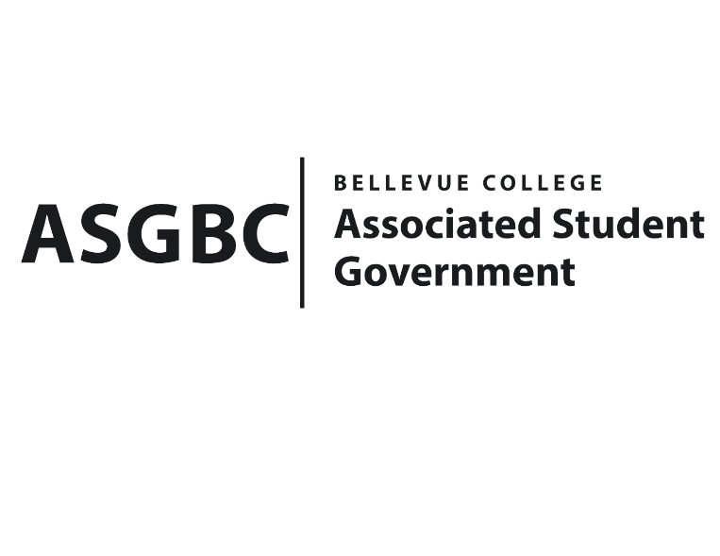
BOARD OF DIRECTORS
Session I
Date: February 16th , 2024
03-01-21

Submitted by Stephanie Nehema, ASG Social Representative

BOARD BILL 03-01-21: An Act to Ratify the SESF Committee Recommendation for the Establishment of the ASG Cap and Gown Loan Program Proposal for $20,020

WHEREAS: The ASG Cap and Gown Loan Program will be providing a rental service for caps, gowns, and stoles to students who may face financial constraints regarding their graduation attire; and,

WHEREAS: Understanding the importance of addressing these financial challenges to ensure that all students can participate fully in graduation ceremonies and celebrate their academic achievements without the burden of excessive expenses; and,

WHEREAS: Acknowledging the positive environmental impact of reduced waste by offering a rental service for caps, gowns, and stoles, which extends the lifecycle of these items and minimizes the overall waste footprint associated with graduation ceremonies;

WHERAS: The ASG Cap and Gown Loan Program proposal was approved by the SESF Committee on February 12th, 2024.

THEREFORE, BE IT ENACTED BY THE ASSOCIATED STUDENT GOVERNMENT OF BELLEVUE COLLEGE BOARD OF DIRECTORS

THAT: The ASG Cap and Gown Loan Program proposal for $20,020 be hereby ratified by the Board of Directors; and,

THAT: A copy of this bill be forwarded to Alicia Keating Polson, Executive Director-President’s Office; Elissa Gordon, Associate Director of Sustainability; Julie Nguyen, ASG Secretary; Sean Behl, ASG President; Rebecca Mbaka, ASG Vice President; and Stephanie Nehema, ASG Social Responsibility Representative.

End

I, Sean Behl, President of the Associated Student Government of Bellevue College, do herby certify that Board Bill 03-01-21 was duly approved by the Board of Directors on 02/16/2024. I attest to the accuracy and authenticity of the contents of this bill.



__________________________________
Sean Behl
ASG President

