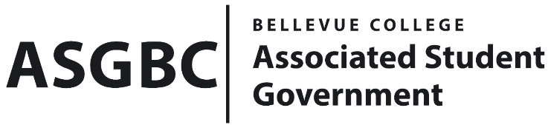
BOARD OF DIRECTORS
Session I
Date: February 16th, 2024
03-01-17

Submitted by Heidi Ngo, Treasurer

BOARD BILL 03-01-17: An Act to Approve the Filmmaking Club’s budget reallocation in the amount of $11,000.

WHEREAS: The Bellevue College Filmmaking Club seeks to move funds from their Good and Services Budget and Travel Budget into their Client Service Contracts and Equipment budget; and

THEREFORE, BE IT ENACTED BY THE ASSOCIATED STUDENT GOVERNMENT OF BELLEVUE COLLEGE BOARD OF DIRECTORS

THAT: The Associated Student Government of Bellevue College approves the reallocation of Filmmaking Club’s budget reallocation in the amount of $11,000; and

THAT: The approved funding is allocated from the Filmmaking Club’s Services Budget and Travel Budget to the Client Services Contracts and Equipment Budget; and

THAT: A copy of this bill be forwarded to Heidi Ngo, Treasurer and Hristo Stoynov, Office of Student Engagement Program Coordinator, Filmmaking Club Advisor, and Claire Teske, Filmmaking Club President.

End
I, Sean Behl, President of the Associated Student Government of Bellevue College, do herby certify that Board Bill 03-01-17 was duly approved by the Board of Directors on 02/16/2024. I attest to the accuracy and authenticity of the contents of this bill.



__________________________________
Sean Behl
ASG President

