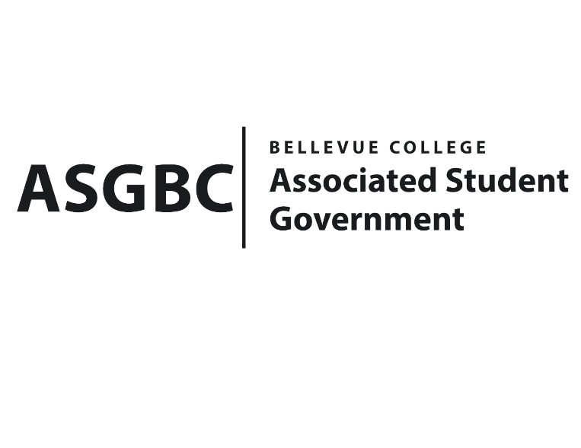
BOARD OF DIRECTORS
Session I
Date: February 16th, 2024
03-01-16

Submitted by Heidi Ngo, Treasurer

BOARD BILL 03-01-16: An Act to Approve the Music Club’s Kick Off Event in the amount of $1200.

WHEREAS: The Bellevue College Music Club plans to host a kickoff event where they introduce their music to the Bellevue College community; and,

WHEREAS: The Bellevue College Music Club aims to introduce members to their visions and goals, foster community and encourage participation in collaborative musical endeavors; and,

WHEREAS: The Bellevue College Music Club aims to create a supportive community where members collaboratively create and publish original music. The kick-off meeting serves as the first step in realizing this vision by bringing together like-minded individuals who share a passion for music creation; and,

WHEREAS: The Bellevue College Music Club plans to purchase food for their event from Bellevue College catering.

THEREFORE, BE IT ENACTED BY THE ASSOCIATED STUDENT GOVERNMENT OF BELLEVUE COLLEGE BOARD OF DIRECTORS

THAT: The Associated Student Government of Bellevue College approves the allocation of $940 to fund the Music Club’s Kick Off Event; and,

THAT: The approved funding is allocated from the ASG General account; and,

THAT: A copy of this bill be forwarded to Heid Ngo, Treasurer and Hristo Stoynov, Office of Student Engagement Program Coordinator. Cynthia Weintraub, Music Club Advisor, and Seungmin Cha, Music Club President.

End
I, Sean Behl, President of the Associated Student Government of Bellevue College, do herby certify that Board Bill 03-01-16 was duly approved by the Board of Directors on 02/16/2024. I attest to the accuracy and authenticity of the contents of this bill.



__________________________________
Sean Behl
ASG President

