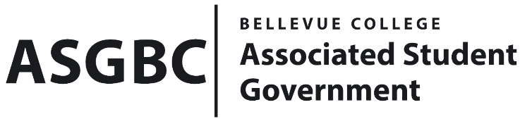
BOARD OF DIRECTORS
Session I
Date: February 9th, 2024
03-01-15

Submitted by Heidi Ngo Treasurer

BOARD BILL 03-01-15: An Act to Approve the Literature Club’s Winter Book Swap Funding Request in the amount of $300.00.

WHEREAS: The Bellevue College Literature Club plans to host a Winter Book Swap event where members bring old or unused books and swap with other members; and

WHEREAS: The Bellevue College Literature Club aims to encourage and inspire reading and literary works to all Bellevue College members and staff; and

WHEREAS: The Bellevue College Literature Club plans to use the funds to purchase boxes and refreshments from Bellevue College catering for the Winter Book Swap.

THEREFORE, BE IT ENACTED BY THE ASSOCIATED STUDENT GOVERNMENT OF BELLEVUE COLLEGE BOARD OF DIRECTORS

THAT: The Associated Student Government of Bellevue College approves the allocation of $94. To fund the Literature Club’s Winter Book Swap Event; and

THAT: The approved funding is allocated from the ASG General account; and,

THAT: A copy of this bill be forwarded to Heid Ngo, Treasurer and Hristo Stoynov, Office of Student Engagement Program Coordinator. Cara Diaconoff Literature Club Advisor, and Lily Sanders, Literature Club President.

End

I, Sean Behl, President of the Associated Student Government of Bellevue College, do herby certify that Board Bill 03-01-15 was duly approved by the Board of Directors on 02/23/2024. I attest to the accuracy and authenticity of the contents of this bill.



__________________________________
Sean Behl
ASG President

