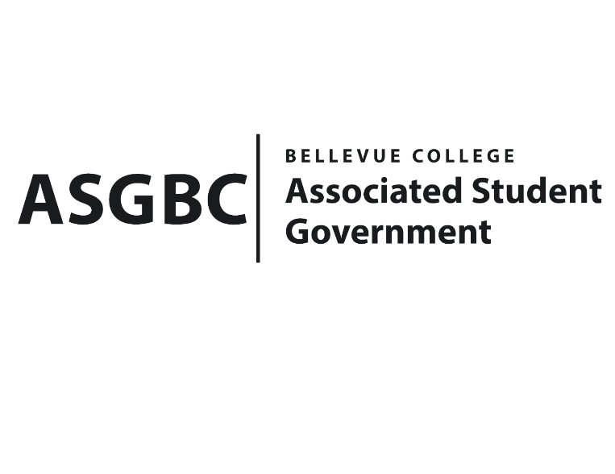
BOARD OF DIRECTORS
Session I
Date: February 9^{h}, 2024
03-01-12

Submitted by Heidi Ngo, Treasurer

BOARD BILL 03-01-12: An Act to Approve the Pan-African Women in Society’s International Women’s Day Celebration Funding Request in the Amount of $17,000.

WHEREAS: The Pan-African Women in Society Club plans to host an event for National Women’s Day, along with UMOJA, BLC, ISA, BSU, and Filmmaking club; and

WHEREAS: The Pan-African Women in Society Club seeks to boost the empowerment of Women from Africa decent by presenting how women were perceive back then VS how they are leading the world right now; and

WHEREAS: The Pan-African Women in Society Club hopes to receive funds to purchase food and DJ performers for the event.

THEREFORE, BE IT ENACTED BY THE ASSOCIATED STUDENT GOVERNMENT OF BELLEVUE COLLEGE BOARD OF DIRECTORS

THAT: The Associated Student Government of Bellevue College approves the allocation of $17,000 to fund the Pan-African Women in Society’s International Women’s Day Celebration

THAT: A copy of this bill be forwarded to Heid Ngo, Treasurer; Hristo Stoynov, Office of Student Engagement Program Coordinator; Oriana Estrada, Pan-African Women in Society Club Advisor; and Geraldine Muyumba, Pan-African Women in Society Club President.

End

I, Sean Behl, President of the Associated Student Government of Bellevue College, do herby certify that Board Bill 03-01-12 was duly approved by the Board of Directors on 02/09/2024. I attest to the accuracy and authenticity of the contents of this bill.



__________________________________
Sean Behl
ASG President

