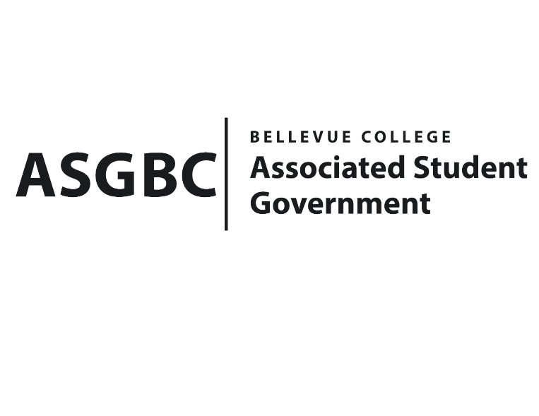
BOARD OF DIRECTORS
Session I
Date: February 2nd, 2024
03-01-11

Submitted by Heidi Ngo, Treasurer

BOARD BILL 03-01-11-: An Act to Approve the Ukrainian Community Intuitive Art Funding Request for $200.

WHEREAS: The Ukrainian Community plans to host a workshop designed to help students tap into their innate artistic abilities, connect with like-minded individuals, and celebrate the vibrant Ukrainian culture within their community; and

WHEREAS: The Ukrainian Community aims to ensure that this event will become a nurturing space for students to explore their creative potential and find relief from the stresses of academic life.

THEREFORE, BE IT ENACTED BY THE ASSOCIATED STUDENT GOVERNMENT OF BELLEVUE COLLEGE BOARD OF DIRECTORS

THAT: The Associated Student Government of Bellevue College approves the allocation of $200 to fund Ukrainian Community Intuitive Art; and,

THAT: The approved funding is allocated from the ASG Cultural account; and,

THAT: A copy of this bill be forwarded to Heidi Ngo, Treasurer; Hristo Stoynov, Office of Student Engagement Program Coordinator; Amanda Arboleda, Student Engagement- Student Involvement Specialist; Oksana Richter, Ukrainian Community Advisor; and Lina Ngo, Ukrainian Community President.

End

I, Sean Behl, President of the Associated Student Government of Bellevue College, do herby certify that Board Bill 03-01-11 was duly approved by the Board of Directors on 02/02/2024. I attest to the accuracy and authenticity of the contents of this bill.

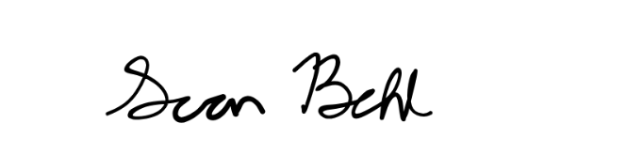

__________________________________
Sean Behl
ASG President

