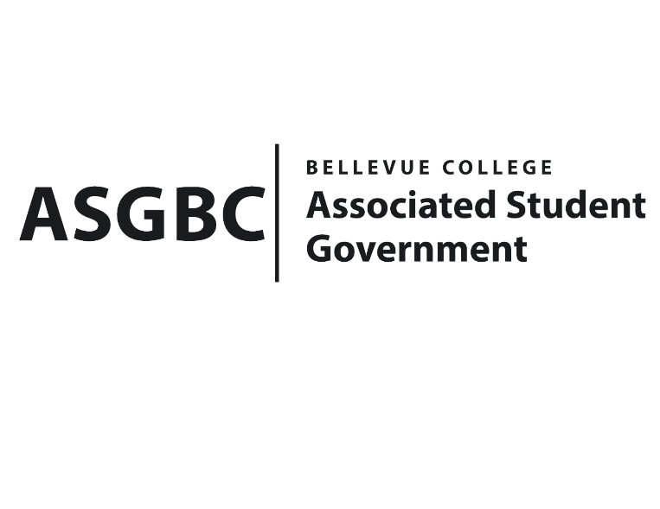
BOARD OF DIRECTORS
Session I
Date: February 2nd, 2024
03-01-10

Submitted by Heidi Ngo, Treasurer

BOARD BILL 03-01-10: An Act to Approve the Indian Student Community Orientation meeting for $500.

WHEREAS: The Indian Student Community plans to host an orientation meeting to inform members about the club and its key aspects including membership, officer positions, and events that will take place throughout the year; and

WHEREAS: The Indian Student Community hopes to create a welcoming space for all, they want to share their mission and club information to potential members through this initial. This orientation meeting is the first step to building a community they can all celebrate Indian Culture.

THEREFORE, BE IT ENACTED BY THE ASSOCIATED STUDENT GOVERNMENT OF BELLEVUE COLLEGE BOARD OF DIRECTORS

THAT: The Associated Student Government of Bellevue College approves the allocation of $240 to fund Indian Student Community Orientation; and,

THAT: The approved funding is allocated from the ASG Cultural account; and,

THAT: A copy of this bill be forwarded to Heidi Ngo, Treasurer; Hristo Stoynov, Office of Student Engagement Program Coordinator; Amanda Arboleda, Student Engagement- Student Involvement Specialist; Leslie Lum, Indian Student Community Advisor; and Diyah Shah, Indian Student Community President.

End

I, Sean Behl, President of the Associated Student Government of Bellevue College, do herby certify that Board Bill 03-01-10 was duly approved by the Board of Directors on 02/02/2024. I attest to the accuracy and authenticity of the contents of this bill.



__________________________________
Sean Behl
ASG President

