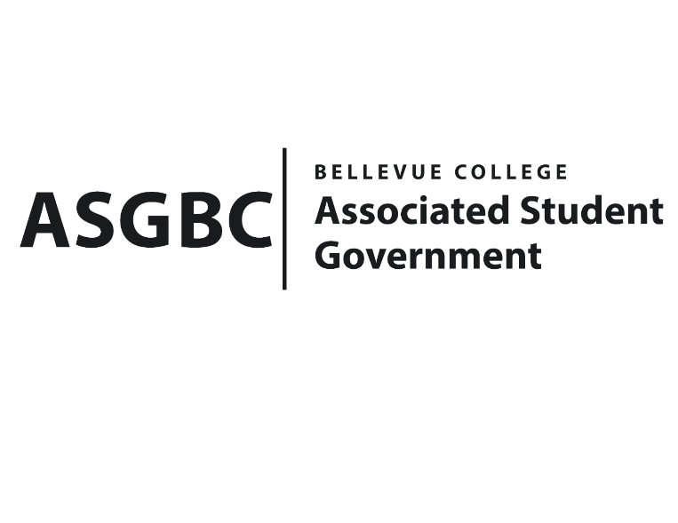
BOARD OF DIRECTORS
Session I
Date: February 2nd, 2024
03-01-09

Submitted by Heidi Ngo, Treasurer

BOARD BILL 03-01-09: An Act to Approve the Robotics Club Boeing Tour Funding Request in the Amount of $1320.

WHEREAS: The Robotics Club plans to attend the tour that Boeing offers of their factory in Everett, it will last around 80 minutes; and

WHEREAS: The Robotics Club plans seek to gain invaluable real-world exposure to advanced robotics in aerospace, directly supporting their Robotics Club's mission to inspire and educate members in technological innovation.

THEREFORE, BE IT ENACTED BY THE ASSOCIATED STUDENT GOVERNMENT OF BELLEVUE COLLEGE BOARD OF DIRECTORS

THAT: The Associated Student Government of Bellevue College approves the allocation of $1320 to fund Robotics Club Boeing Tour; and,

THAT: The approved funding is allocated from the ASG General account; and,

THAT: A copy of this bill be forwarded to Heidi Ngo, Treasurer; Hristo Stoynov, Office of Student Engagement Program Coordinator; Frank Lee, Robotics Club Advisor; and Brandon Lowder, Robotics Club President.

End

I, Sean Behl, President of the Associated Student Government of Bellevue College, do herby certify that Board Bill 03-01-09 was duly approved by the Board of Directors on 02/02/2024. I attest to the accuracy and authenticity of the contents of this bill.



__________________________________
Sean Behl
ASG President

