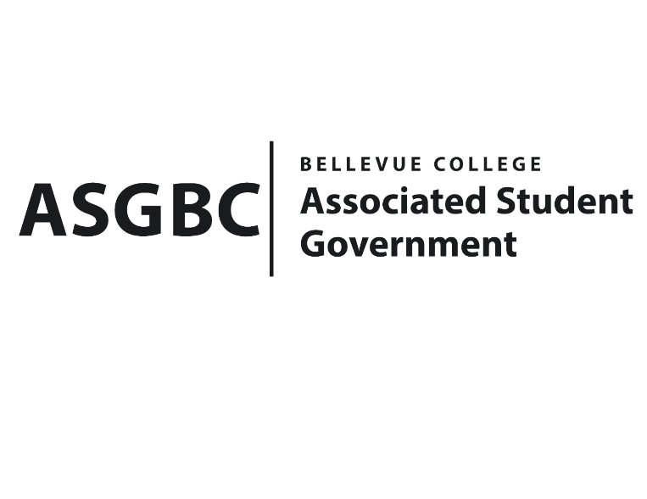
BOARD OF DIRECTORS
Session I
Date: January 26^{h}, 2024
03-01-07

Submitted by Heidi Ngo, Treasurer

BOARD BILL 03-01-07: An Act to the Math and Poetry Club Math Fair Funding Request in the Amount of $2570.23.

WHEREAS: The Math and Poetry Club seeks to receive funds to host a "Math Fair". This event strives to increase student's interest and enthusiasm for math, fostering a fresh and engaging approach to learning, reducing math's stress, and introducing more enjoyable comprehensible methods and therefore more fun; and,

WHEREAS: The Math and Poetry Club hopes to portray a fun aspect of Math, the "Math Fair" event will significantly meet the vision and mission of the club which consist of making Math fun through various activities enabling student to think and engage with their surroundings.

THEREFORE, BE IT ENACTED BY THE ASSOCIATED STUDENT GOVERNMENT OF BELLEVUE COLLEGE BOARD OF DIRECTORS

THAT: The Associated Student Government of Bellevue College approves the allocation of $2570.23 to fund the Math and Poetry Club Math Fair; and,

THAT: The approved funding is allocated from the ASG General account; and,

THAT: A copy of this bill be forwarded to Heid Ngo, Treasurer and Hristo Stoynov, Office of Student Engagement Program Coordinator. Corvilia Thykkuttathil, Math and Poetry Club Advisor, and Vallon Bosango, Math and Poetry Club President.

End

I, Sean Behl, President of the Associated Student Government of Bellevue College, do herby certify that Board Bill 03-01-07 was duly approved by the Board of Directors on 02/09/2024. I attest to the accuracy and authenticity of the contents of this bill.



__________________________________
Sean Behl
ASG President

