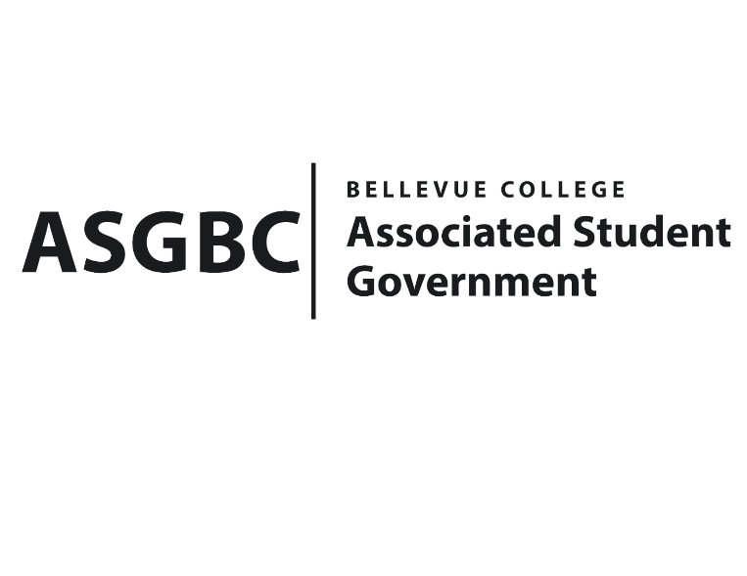
BOARD OF DIRECTORS
Session I
Date: February 2nd, 2024
01-01-01

Submitted by Sean Behl, President

BOARD BILL 01-01-01: An Act to Amend the ASG Bylaws
WHEREAS: The ASG Bylaws as currently written require vast amendments to streamline, organize, and make operations of the Associated Student Government more effective and efficient; and,

WHEREAS: Sean Behl presents a vastly restructured ASG Bylaws that includes document-wide changes, and major reformatting; and,

WHEREAS: These changes include major amendments to sections of the bylaws regarding hiring, elections, committees, and student organizations; and,

WHEREAS: These changes also include; the implementation of a record keeping and reports system to ensure that future teams and the public have access to ASG information; the addition of clear procedures for adopting the association’s legislative agenda; the establishment of clear expectations and processes for appointing/removing ASG Advisors; and the adoption of sessions, with the first session of the ASG concluding on the thirtieth day of June in the year two thousand twenty-four; and,

WHEREAS: These changes also included an addendum which shall provide the Board of Directors the ability to operate as currently defined, and to prepare for, and complete procedures such as hiring, for the position changes becoming effective on the first day of July in the year two thousand twenty-four; and,

WHEREAS: These amendments are necessary for the effective and efficient operations of the Associated Student Government of Bellevue College.

THEREFORE, BE IT ENACTED BY THE ASSOCIATED STUDENT GOVERNMENT OF BELLEVUE COLLEGE BOARD OF DIRECTORS

THAT: The Board of Directors hereby adopts the ASG Bylaws amendments as presented; and,

THAT: The ASG Secretary and ASG Emerging Technology Representative ensure that the amended document is archived and made public; and,

THAT: A copy of this bill be forwarded to all current ASG personnel; Mike Kaptik, ASG Advisor and Dean of Student Life and Leadership; Amy McCrory, ASG Advisor; and Bradely Huggins, Director of Student Engagement.

End

I, Sean Behl, President of the Associated Student Government of Bellevue College, do herby certify that Board Bill 01-01-01 was duly approved by the Board of Directors on 02/02/2024. I attest to the accuracy and authenticity of the contents of this bill.



__________________________________
Sean Behl
ASG President

