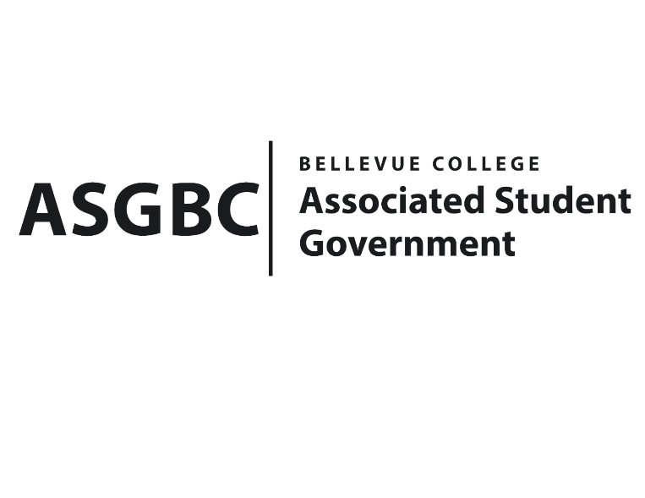
BOARD OF DIRECTORS
Session I
Date: January 26th, 2024
04-01-19

Submitted by Heidi Ngo, Treasurer

BOARD BILL 04-01-19: An Act to Approve the Charter of the Bellevue College Vibrant Vietnam Club.
WHEREAS: The Bellevue College Vibrant Vietnam Club aims to organize various workshops and activities which can help students find out more about Vietnamese culture. They also want to help students find out more about the diversity in cuisine, accent, and more of Viet Nam, they also want to become a space where new students from Viet-Nam can get familiarized with the lifestyle of Washington State and rebound with the culture in their home country.
WHEREAS: The Bellevue Vibrant Vietnam Club aims to get a good understanding of Vietnamese language and cuisine. They also want to participate in interesting activities relating to Vietnamese culture with friends. They want to create a place for Vietnamese students to rebound with their home country’s culture. They also want to create a hangout space to make friends and immerse in Vietnamese culture at the same time.
WHEREAS: The Bellevue College Vibrant Vietnam Club has met all required qualifications to become a chartered student organization.
WHEREAS: This charter shall expire on June 30th, 2024, unless otherwise renewed by the club with ratification from the Board of Directors.
THEREFORE, BE IT ENACTED BY THE ASSOCIATED STUDENT GOVERNMENT OF BELLEVUE COLLEGE BOARD OF DIRECTORS
THAT: The Associated Student Government hereby recognizes the Bellevue College Vibrant Vietnam Club as an official student organization at Bellevue College.
THAT: A copy of this bill be forwarded to Julie Nguyen, ASG Secretary; Joyce Diakubama, ASG Public Relations Representative; Amanda Arboleda, Student Engagement- Student Involvement Specialist; Doan Pham, Bellevue College Vibrant Vietnam Club President; and Hai Thanh Vo, Bellevue College Vibrant Vietnam Club Vice President.

End

I, Sean Behl, President of the Associated Student Government of Bellevue College, do herby certify that Board Bill 04-01-19 was duly approved by the Board of Directors on 01/26/2024. I attest to the accuracy and authenticity of the contents of this bill.


__________________________________
Sean Behl
ASG President

