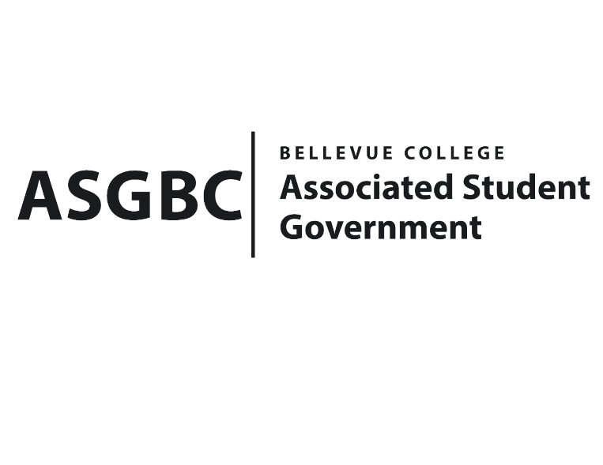
BOARD OF DIRECTORS
Session I
Date: January 26th, 2024
04-01-18

Submitted by Heidi Ngo, Treasurer

BOARD BILL 04-01-18: An Act to Approve the Charter of the Bellevue College Taiko Club.
WHEREAS: The Bellevue College Taiko aims to share the tradition and culture surrounding the performance of the Japanese percussion instrument, Taiko (otherwise, Japanese drums). They aim to encourage members to learn and gain the ability of playing the instrument, guided by lessons taught by a teacher well rounded in Taiko. This may include achieving proficiency in Taiko (starting from a beginner level), involve techniques, tempo, performance and rhythmic styles; learning to perform not only individually, but also as an ensemble; and
WHEREAS: The Bellevue Taiko Club provides a social interaction space within Bellevue College. By experiencing art of various cultures, they can provide members and students with new discoveries and values. They hope to provide a fun and goal for our members, while receiving a rigorous workout. Through Taiko drumming, you can liven up events on campus and make the place more attractive and purposeful.
WHEREAS: The Bellevue College Taiko Club has met all required qualifications to become a chartered student organization.
WHEREAS: This charter shall expire on June 30th, 2024, unless otherwise renewed by the club with ratification from the Board of Directors.
THEREFORE, BE IT ENACTED BY THE ASSOCIATED STUDENT GOVERNMENT OF BELLEVUE COLLEGE BOARD OF DIRECTORS
THAT: The Associated Student Government hereby recognizes the Bellevue College Taiko Club as an official student organization at Bellevue College.
THAT: A copy of this bill be forwarded to Julie Nguyen, ASG Secretary; Joyce Diakubama, ASG Public Relations Representative; Amanda Arboleda, Student Engagement- Student Involvement Specialist; Seinosuke Ueda, Bellevue College Taiko Club President; and Tarabini Azis, Bellevue College Taiko Club Co- President.

End

I, Sean Behl, President of the Associated Student Government of Bellevue College, do herby certify that Board Bill 04-01-18 was duly approved by the Board of Directors on 01/26/2024. I attest to the accuracy and authenticity of the contents of this bill.


__________________________________
Sean Behl
ASG President

