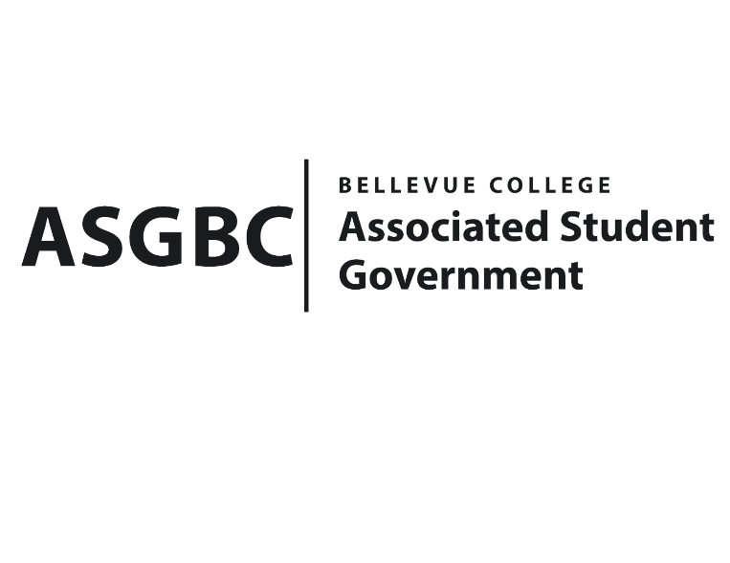
BOARD OF DIRECTORS
Session I
Date: January 26th, 2024
04-01-17

Submitted by Heidi Ngo, Treasurer

BOARD BILL 04-01-17: An Act to Approve the Charter of the Bellevue College Chess Club.

WHEREAS: The Bellevue College Chess Club aims to create a diverse, welcoming environment for students to play chess and make friends.
WHEREAS: The Bellevue Chess Club is a massive intellectual sport, and it benefits the BC community to have a club dedicated to playing peers in person. It fosters engagement and a sense of community.
WHEREAS: The Bellevue College Chess Club has met all required qualifications to become a chartered student organization.
WHEREAS: This charter shall expire on June 30th, 2024, unless otherwise renewed by the club with ratification from the Board of Directors.
THEREFORE, BE IT ENACTED BY THE ASSOCIATED STUDENT GOVERNMENT OF BELLEVUE COLLEGE BOARD OF DIRECTORS
THAT: The Associated Student Government hereby recognizes the Bellevue College Chess Club as an official student organization at Bellevue College.
THAT: A copy of this bill be forwarded to Julie Nguyen, ASG Secretary; Joyce Diakubama, ASG Public Relations Representative; Amanda Arboleda, Student Engagement- Student Involvement Specialist; Harlan Lee, Bellevue College Chess Club President; and Oliver Buehrer, Bellevue College Chess Club President.

End

I, Sean Behl, President of the Associated Student Government of Bellevue College, do herby certify that Board Bill 04-01-17 was duly approved by the Board of Directors on 01/26/2024. I attest to the accuracy and authenticity of the contents of this bill.


__________________________________
Sean Behl
ASG President

