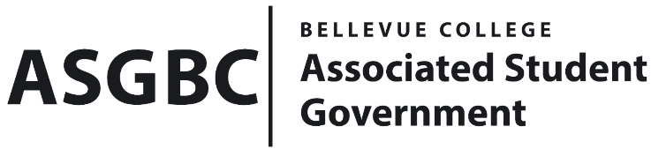
BOARD OF DIRECTORS
Session I
Date: January 19th, 2024
04-01-16

Submitted by Heidi Ngo, Treasurer

BOARD BILL 04-01-16: An Act to Approve the Charter of Bellevue College Association of Veterans.

WHEREAS: The Bellevue College Association of Veterans is dedicated to supporting veteran students pursuing higher education because they feel like they are too old to go to school and they have been away from academic environments for years. The Bellevue College Association of Veterans wants to re-charter the veterans club to gather veteran students to connect with each other to share each student's academic success to ease imposter syndrome and promote confidence in veteran students and would like to have one stop shop for veteran students that could share programs for veterans for them to contribute their academic success.

WHEREAS: The Bellevue College Association of Veterans provides U.S. military veterans' academic success here at Bellevue College. It will encourage veteran students to keep pursuing their academic goal. It will gather veteran students to connect with each other and provide a sense of sentimental belonging.

WHEREAS: The Bellevue College Association of Veterans has met all required qualifications to become a chartered student organization.

WHEREAS: This charter shall expire on June 30th, 2024, unless otherwise renewed by the club with ratification from the Board of Directors.

THEREFORE, BE IT ENACTED BY THE ASSOCIATED STUDENT GOVERNMENT OF BELLEVUE COLLEGE BOARD OF DIRECTORS

THAT: The Associated Student Government hereby recognizes the Bellevue College Association of Veterans as an official student organization at Bellevue College.

THAT: A copy of this bill be forwarded to Julie Nguyen, ASG Secretary; Joyce Diakubama, ASG Public Relations Representative; Amanda Arboleda, Student Engagement- Student Involvement Specialist; Gyeongrok Jeong, Bellevue College Association of Veteran President; and Areil Alejo, Bellevue College Association of Veteran Vice President.

End

I, Sean Behl, President of the Associated Student Government of Bellevue College, do herby certify that Board Bill 04-01-16 was duly approved by the Board of Directors on 01/19/2024. I attest to the accuracy and authenticity of the contents of this bill.


__________________________________
Sean Behl
ASG President

