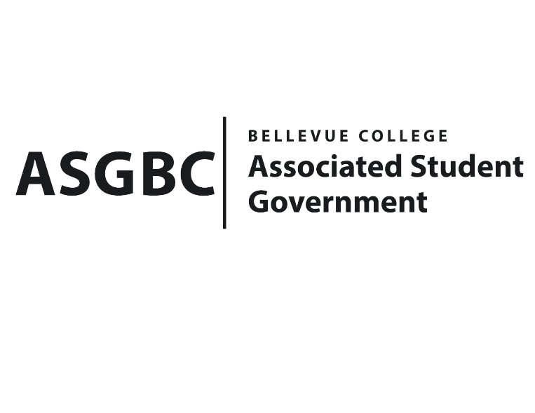
BOARD OF DIRECTORS
Session I
Date: January 19th, 2024
04-01-15

Submitted by Heidi Ngo, Treasurer

BOARD BILL 04-01-15: An Act to Approve the Charter of the African and Arab Student Association.
WHEREAS: The Bellevue College African and Arab Student Association is dedicated to host cultural events that showcase the traditions, music, dance, art, and cuisine of African and Arab nations and collaborate with members to organize cultural nights, where students can share and celebrate their unique heritage. They hope to organize workshops, seminars, and presentations to educate the broader student body about the history, languages, and customs of African and Arab cultures. They want to host discussions on relevant topics, encouraging cross-cultural dialogue and understanding. Collaborate with existing charitable organizations to contribute to causes that impact the regions represented in the club. Plan social gatherings, mixers, and outings to provide opportunities for members to connect on a personal level, building friendships and a sense of community. They aim to raise awareness about issues relevant to African and Arab communities within the college. They want to organize campaigns to challenge stereotypes and promote a more nuanced understanding of the diverse cultures represented in the club. And lastly, they hope to forge partnerships with other cultural and student organizations to create a supportive network that enhances the overall college experience for everyone.

WHEREAS: The Bellevue College African and Arab Student Association provides members with the opportunity to immerse themselves in the rich cultural traditions, languages, and customs of Africa and the Arab world. This exposure will enhance their cultural awareness and understanding. The club aims to foster a sense of belonging and community among African and Arab students, creating a supportive environment where they can share their experiences, challenges, and successes. Especially for new students at Bellevue College, finding an organization they fit into will make them feel welcomed. Social events and gatherings provide a platform for students to build meaningful connections and friendships with peers who share a common heritage or interest in African and Arab cultures. The club contributes to the overall cultural diversity of the college campus, creating an inclusive environment, and the activities of the club promote cross-cultural understanding among students, faculty, and staff, creating an atmosphere of tolerance and respect for diverse perspectives. Cultural events organized by our club add vibrancy to campus life, offering entertainment and educational opportunities for the entire college community.

WHEREAS: The Bellevue College African and Arab Student Association has met all required qualifications to become a chartered student organization.

WHEREAS: This charter shall expire on June 30th, 2024, unless otherwise renewed by the club with ratification from the Board of Directors.

THEREFORE, BE IT ENACTED BY THE ASSOCIATED STUDENT GOVERNMENT OF BELLEVUE COLLEGE BOARD OF DIRECTORS

THAT: The Associated Student Government hereby recognizes the African and Arab Student Association as an official student organization at Bellevue College.
THAT: A copy of this bill be forwarded to Julie Nguyen, ASG Secretary; Joyce Diakubama, ASG Public Relations Representative; Amanda Arboleda, Student Engagement- Student Involvement Specialist; Jude Goreish, African and Arab Student Association President; and Falhado Mohamed, African and Arab Student Association Vice President.

End

I, Sean Behl, President of the Associated Student Government of Bellevue College, do herby certify that Board Bill 04-01-15 was duly approved by the Board of Directors on 01/19/2024. I attest to the accuracy and authenticity of the contents of this bill.


__________________________________
Sean Behl
ASG President

