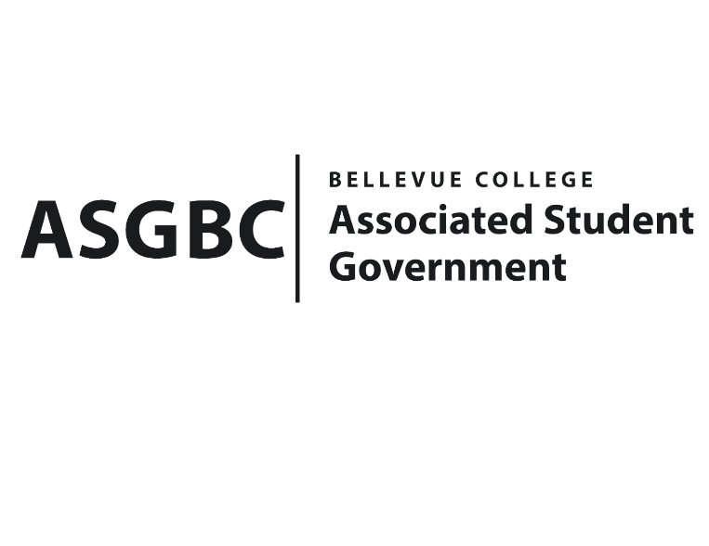
BOARD OF DIRECTORS
Session I
Date: January 19th, 2024
04-01-14

Submitted by Heidi Ngo, Treasurer

BOARD BILL 04-01-14: An Act to Approve the Charter of the Korean Student Association.
WHEREAS: The Bellevue College Korean Student is dedicated to establishing a dynamic and supportive community for international students with an interest in Korean culture, actively promoting cultural exchange and understanding within both its membership and the wider university community. Through a range of events, workshops, and initiatives, the KSA is committed to showcasing and enhancing appreciation for Korean culture, while also offering valuable resources for academic and professional development. In addition to advocating for the needs of Korean students on campus, the KSA focuses on building connections, fostering diversity, and encouraging global understanding. They offer international students, whether they have an interest or are unfamiliar with Korean culture, the chance to immerse themselves in and gain a better understanding of Korea. Their aim is to facilitate learning about diverse cultures, providing a gateway for students to explore and appreciate the uniqueness of Korean traditions.
WHEREAS: The Bellevue College Korean Student Association provides numerous benefits to students and the broader campus community. First, it serves as a platform for cultural enrichment, offering students, both Korean and non-Korean, opportunities to engage with and learn about Korean trendy, language, and customs. Through events and activities, the KSA fosters cultural exchange, contributing to a more globally aware and interconnected campus. By organizing diverse events and initiatives, the KSA adds vibrancy to the campus, promoting diversity, inclusivity, and understanding. Overall, the KSA enhances the overall college experience by fostering cultural appreciation, community building, and personal growth among students.
WHEREAS: The Bellevue College Korean Student Association has met all required qualifications to become a chartered student organization.

WHEREAS: This charter shall expire on June 30th, 2024, unless otherwise renewed by the club with ratification from the Board of Directors.
THEREFORE, BE IT ENACTED BY THE ASSOCIATED STUDENT GOVERNMENT OF BELLEVUE COLLEGE BOARD OF DIRECTORS

THAT: The Associated Student Government hereby recognizes the Korean Student Association as an official student organization at Bellevue College.
THAT: A copy of this bill be forwarded to Julie Nguyen, ASG Secretary; Joyce Diakubama, ASG Public Relations Representative; Amanda Arboleda, Student Engagement- Student Involvement Specialist; SeungBum Yoo, Korean Student Association President; and Alieen Song, Korean Student Association Vice President.

End

I, Sean Behl, President of the Associated Student Government of Bellevue College, do herby certify that Board Bill 04-01-14 was duly approved by the Board of Directors on 01/19/2024. I attest to the accuracy and authenticity of the contents of this bill.


__________________________________
Sean Behl
ASG President

