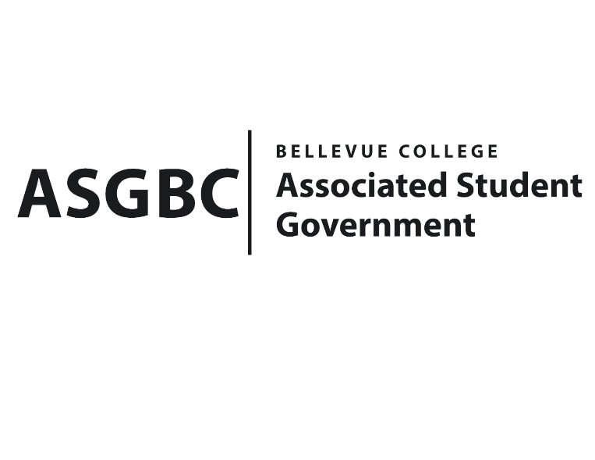
BOARD OF DIRECTORS
Session I
Date: January 12th, 2024
04-01-13

Submitted by Sean Behl, President

BOARD BILL 04-01-13: An Act to Ratify the SESF Committee Recommendation to Approve the Washington Oregon Higher Education Sustainability Conference Proposal for $6,089

WHEREAS: The Washington Oregon Higher Education Sustainability Conference proposal will provide the opportunity to bring eight students to the Washington Oregon Higher Education Sustainability Conference to learn more about sustainable practices in general, but especially in higher education; and,

WHERAS: The Washington Oregon Higher Education Sustainability Conference proposal was approved by the SESF Committee on January 9th, 2024 by a vote of (4-0-1).

THEREFORE, BE IT ENACTED BY THE ASSOCIATED STUDENT GOVERNMENT OF BELLEVUE COLLEGE BOARD OF DIRECTORS

THAT: The Washington Oregon Higher Education Sustainability Conference proposal for $6,089 be hereby ratified by the Board of Directors; and,

THAT: A copy of this bill be forwarded to Sara Holzknecht, Director of Sustainability; Elissa Gordon, Associate Director of Sustainability; Julie Nguyen, ASG Secretary; and Stephanie Nehema, ASG Social Responsibility Representative.

End

I, Sean Behl, President of the Associated Student Government of Bellevue College, do herby certify that Board Bill 04-01-13 was duly approved by the Board of Directors on 01/12/2024. I attest to the accuracy and authenticity of the contents of this bill.


__________________________________
Sean Behl
ASG President

