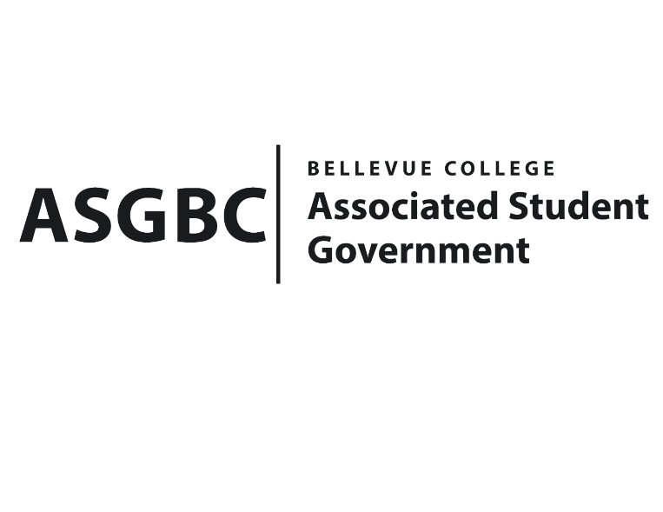
BOARD OF DIRECTORS
Session I
Date: January 12th, 2024
04-01-12

Submitted by Sean Behl, President

BOARD BILL 04-01-12: An Act to Ratify the SESF Sustainability Fair Proposal for $20,000

WHEREAS: The SESF Sustainability Fair will serve as an opportunity for students to engage with and learn more about the SESF Committee and sustainability practices at Bellevue College; and,

WHEREAS: The SESF Sustainability Fair proposal consists of a $10,000 request to purchase SESF merchandise and prizes for students that will be distributed throughout the rest of the academic year; and,

WHERAS: The SESF Sustainability Fair proposal was approved by the SESF Committee on January 9th, 2024 by a vote of (4-0-1).

THEREFORE, BE IT ENACTED BY THE ASSOCIATED STUDENT GOVERNMENT OF BELLEVUE COLLEGE BOARD OF DIRECTORS

THAT: The SESF Sustainability Fair proposal for $20,000 be hereby ratified by the Board of Directors; and,

THAT: A copy of this bill be forwarded to Sara Holzknecht, Director of Sustainability; Elissa Gordon, Associate Director of Sustainability; Julie Nguyen, ASG Secretary; and Stephanie Nehema, ASG Social Responsibility Representative.

End

I, Sean Behl, President of the Associated Student Government of Bellevue College, do herby certify that Board Bill 04-01-12 was duly approved by the Board of Directors on 01/12/2024. I attest to the accuracy and authenticity of the contents of this bill.


__________________________________
Sean Behl
ASG President

