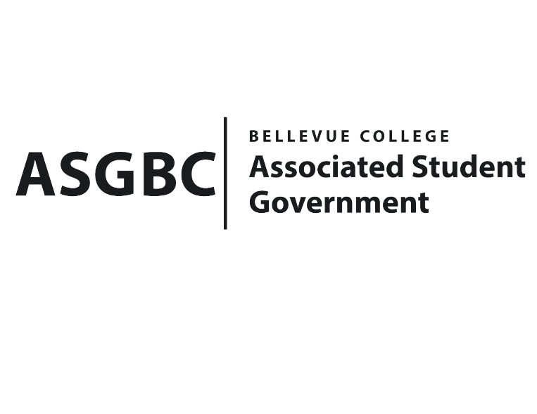
BOARD OF DIRECTORS
Session I
Date: January 12th, 2024
04-01-11

Submitted by Heidi Ngo, Treasurer

BOARD BILL 04-01-11: An Act to Approve the Charter of the Taiwanese Student Association.
WHEREAS: The Bellevue College Taiwanese Student Association strives to explore what it feels like to wander the night markets. Explore the festivals that take place in Taiwan like the mid-autumn festival and most famously, Lunar New Year. In this club, they strive not only to make these events happen but to also create a space where people can be themselves and make new friends from all walks of life.
WHEREAS: The Bellevue College Taiwanese Student Association strives to be a safe place for people to let down their shields and be themselves while experiencing what Taiwanese Culture has to offer. Furthermore, they hope this club is a place where anyone whether they are in their first quarter of college or in their final quarter before graduating can come here and make friendships that will last more than a lifetime. By the time their members leave this club to pursue their dreams or transfer to other colleges, they hope they will not only have experienced Taiwanese Culture but also meet people who will become their lifelong friends.
WHEREAS: The Bellevue College Taiwanese Student Association has met all required qualifications to become a chartered student organization.

WHEREAS: This charter shall expire on June 30th, 2024, unless otherwise renewed by the club with ratification from the Board of Directors.
THEREFORE, BE IT ENACTED BY THE ASSOCIATED STUDENT GOVERNMENT OF BELLEVUE COLLEGE BOARD OF DIRECTORS

THAT: The Associated Student Government hereby recognizes the Taiwanese Student Association as an official student organization at Bellevue College.
THAT: A copy of this bill be forwarded to Julie Nguyen, ASG Secretary; Joyce Diakubama, ASG Public Relations Representative; Amanda Arboleda, Student Engagement- Student Involvement Specialist; Emily Liu, Taiwanese Student Association President; and Yiyuan Xia Taiwanese Student Association Vice President.

End

I, Sean Behl, President of the Associated Student Government of Bellevue College, do herby certify that Board Bill 04-01-11 was duly approved by the Board of Directors on 01/12/2024. I attest to the accuracy and authenticity of the contents of this bill.


__________________________________
Sean Behl
ASG President

