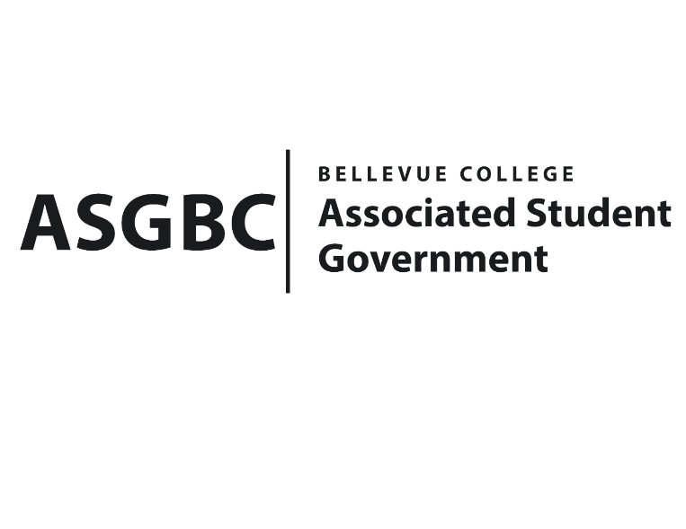
BOARD OF DIRECTORS
Session I
Date: January 12th, 2024
04-01-10

Submitted by Heidi Ngo, Treasurer

BOARD BILL 04-01-10: An Act to Approve the Charter of the Pre-Dental Club.
WHEREAS: The Bellevue College Pre-Dental Club strives to introduce students to the dental profession and provide a caring environment for success in their pre-dental path.
WHEREAS: The Bellevue College Pre-Dental Club strives to help students prepare for dental school prerequisites, the DAT, and opportunities that will increase their chances of getting into dental school.
WHEREAS: The Bellevue College Pre-Dental Club has met all required qualifications to become a chartered student organization.

WHEREAS: This charter shall expire on June 30th, 2024, unless otherwise renewed by the club with ratification from the Board of Directors.
THEREFORE, BE IT ENACTED BY THE ASSOCIATED STUDENT GOVERNMENT OF BELLEVUE COLLEGE BOARD OF DIRECTORS
THAT: The Associated Student Government hereby recognizes the Pre-Dental Club as an official student organization at Bellevue College.
THAT: A copy of this bill be forwarded to Julie Nguyen, ASG Secretary; Joyce Diakubama, ASG Public Relations Representative; Amanda Arboleda, Student Engagement- Student Involvement Specialist; Natalie Neal, Pre-Dental Club President; and Evelyn Kuo Pre-Dental Club Vice President.

End

I, Sean Behl, President of the Associated Student Government of Bellevue College, do herby certify that Board Bill 04-01-10 was duly approved by the Board of Directors on 01/12/2024. I attest to the accuracy and authenticity of the contents of this bill.


__________________________________
Sean Behl
ASG President

