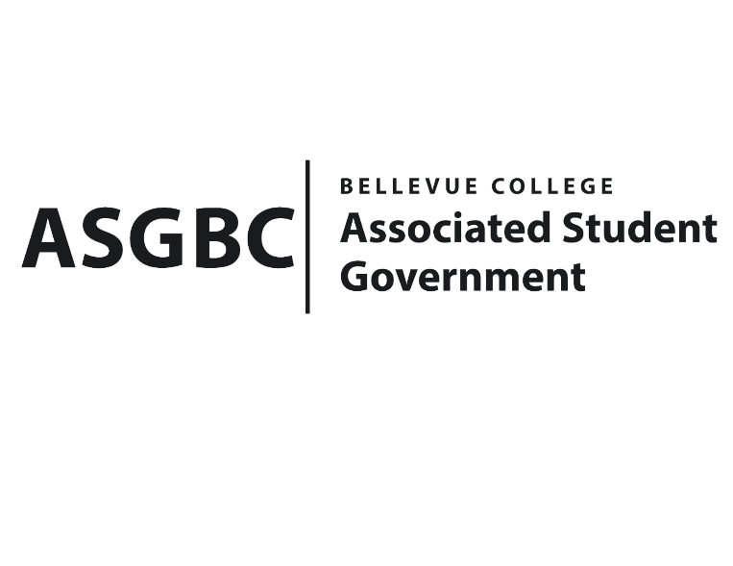
BOARD OF DIRECTORS
Session I
Date: January 12th, 2024
04-01-08

Submitted by Heidi Ngo, Treasurer

BOARD BILL 04-01-08: An Act to Approve the Charter of the Indian Student Community Club.
WHEREAS: The Bellevue College Indian Student Community Club strives to celebrate Indian culture and build a supportive group that all Bellevue College students are welcome in. Through festivals, gatherings, and other activities the Indian Student Community aims to strengthen bonding while spreading awareness about Indian traditions.
WHEREAS: The Bellevue College Indian Student Community Club strives to create a safe space for all students while proudly representing Indian culture. Their goal is to provide a community for those wanting to connect with others of the same interests and/or origins.
WHEREAS: The Bellevue College Indian Student Community Club has met all required qualifications to become a chartered student organization.

WHEREAS: This charter shall expire on June 30th, 2024, unless otherwise renewed by the club with ratification from the Board of Directors.

THEREFORE, BE IT ENACTED BY THE ASSOCIATED STUDENT GOVERNMENT OF BELLEVUE COLLEGE BOARD OF DIRECTORS

THAT: The Associated Student Government hereby recognizes the Indian Student Community Club as an official student organization at Bellevue College.
THAT: A copy of this bill be forwarded to Julie Nguyen, ASG Secretary; Joyce Diakubama, ASG Public Relations Representative; Amanda Arboleda, Student Engagement- Student Involvement Specialist; Dihah Shah, Indian Student Community Club President; and Manishka Narayan Indian Student Community Club Vice President.End

I, Sean Behl, President of the Associated Student Government of Bellevue College, do herby certify that Board Bill 04-01-08 was duly approved by the Board of Directors on 01/12/2024. I attest to the accuracy and authenticity of the contents of this bill.

__________________________________
Sean Behl
ASG President

