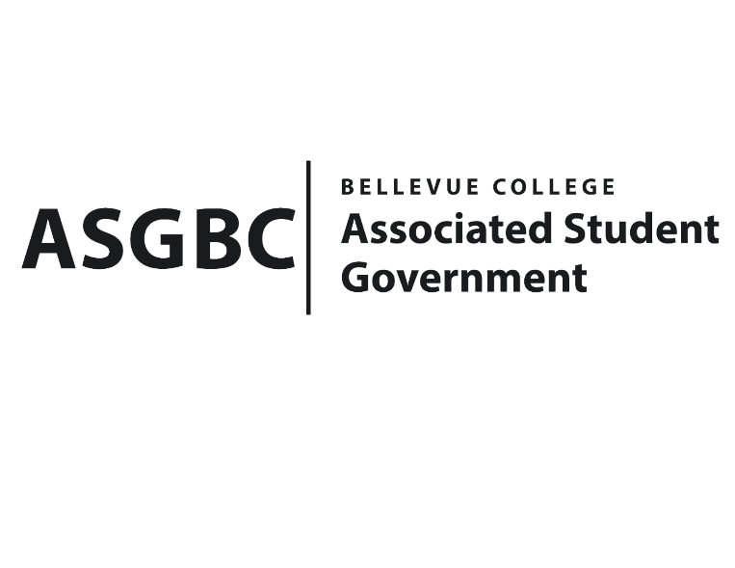
BOARD OF DIRECTORS
Session I
Date: January 12th, 2024
04-01-06

Submitted by Heidi Ngo, Treasurer

BOARD BILL 04-01-06: An Act to Approve the Charter of the Collimator Club.
WHEREAS: The Bellevue College Collimator Club strives to foster a vibrant and supportive community within the radiologic technology program. They are deeply committed to recognizing the invaluable contributions of second- year students, who pave the way for success and set the bar high for excellence. Through planning and executing their Pinning Ceremony, they express their heartfelt appreciation for their dedication and hard work, ensuring they feel acknowledged and celebrated at the end of their rigorous journey.
WHEREAS: The Bellevue College Collimator Club strives to create a family-like atmosphere where everyone feels valued and embraced from the start. Their goal is to seamlessly integrate new members into the Radiologic Technology family, offering a sense of belonging and support as they embark on their educational journey. Together, they strive to enrich the experiences of all their students, building connections that last a lifetime.
WHEREAS: The Bellevue College Collimator Club has met all required qualifications to become a chartered student organization.

WHEREAS: This charter shall expire on June 30th, 2024, unless otherwise renewed by the club with ratification from the Board of Directors.

THEREFORE, BE IT ENACTED BY THE ASSOCIATED STUDENT GOVERNMENT OF BELLEVUE COLLEGE BOARD OF DIRECTORS

THAT: The Associated Student Government hereby recognizes the Collimator Club as an official student organization at Bellevue College.
THAT: A copy of this bill be forwarded to Julie Nguyen, ASG Secretary; Joyce Diakubama, ASG Public Relations Representative; Amanda Arboleda, Student Engagement- Student Involvement Specialist; Jennifer Diaz, Collimator Club President; and Laura Fairbairn, Collimator Club Vice President.

End

I, Sean Behl, President of the Associated Student Government of Bellevue College, do herby certify that Board Bill 04-01-06 was duly approved by the Board of Directors on 01/12/2024. I attest to the accuracy and authenticity of the contents of this bill.


__________________________________
Sean Behl
ASG President

