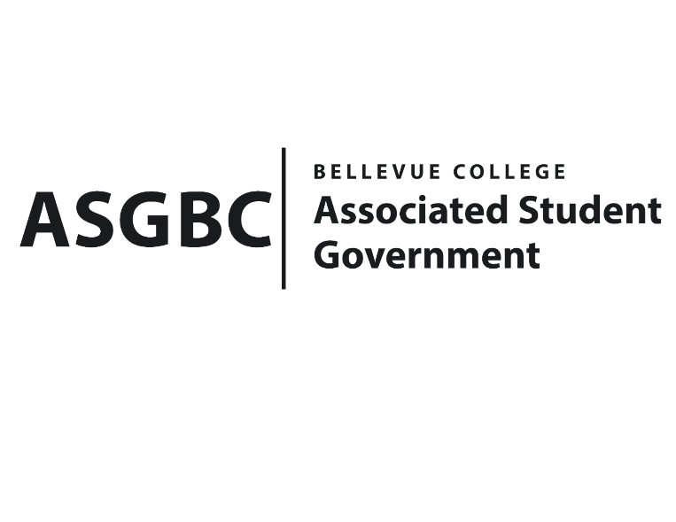
BOARD OF DIRECTORS
Session I
Date: January 12th, 2024
04-01-04

Submitted by Heidi Ngo, Treasurer

BOARD BILL 04-01-04: An Act to Approve the Charter of the Possibilities Club.
WHEREAS: The Bellevue College Possibilities Club strives to swing open the doors to a diverse range of activities for students, strengthening connections with the school, and providing everyone with a warm space to discover their unique place.

WHEREAS: The Bellevue College Possibilities Club strives to create a diverse array of extracurricular activities, including debates, handicrafts, board games, outdoor adventures, and more.

WHEREAS: The Bellevue College Possibilities Club has met all required qualifications to become a chartered student organization.

WHEREAS: This charter shall expire on June 30th, 2024, unless otherwise renewed by the club with ratification from the Board of Directors.

THEREFORE, BE IT ENACTED BY THE ASSOCIATED STUDENT GOVERNMENT OF BELLEVUE COLLEGE BOARD OF DIRECTORS

THAT: The Associated Student Government hereby recognizes the Possibilities Club as an official student organization at Bellevue College.

THAT: A copy of this bill be forwarded to Julie Nguyen, ASG Secretary; Joyce Diakubama, ASG Public Relations Representative; Amanda Arboleda, Student Engagement- Student Involvement Specialist; Heija Jin, Possibilities Club President; and Hailun Yang Possibilities Club Vice President.

End

I, Sean Behl, President of the Associated Student Government of Bellevue College, do herby certify that Board Bill 04-01-04 was duly approved by the Board of Directors on 01/12/2024. I attest to the accuracy and authenticity of the contents of this bill.


__________________________________
Sean Behl
ASG President

